

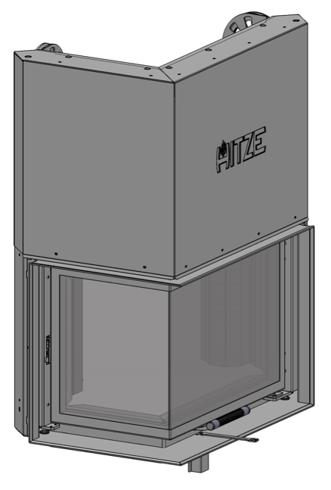

Version 0.0 – 18.10.2016

SETTING AND ADJUSTMENT INSTRUCTIONS

REPLACEMENT OF THE LOCK

**GUILLOTINE-TYPE**

**DOOR**

# REPLACEMENT OF THE DOOR LOCK

**The lock in the door of right-sided or left-sided inserts should be replaced as follows:**

* move the guillotine-type door to its lowest position until it touches the adjustment screws on the stopper of the sliding device;
* press down the lever protruding from the side of the wall to release the pin in the door lock (the lever is on the right or left side of the insert);
* open the door holding the handle;
* unscrew the two M5x10 screws with an Allen (hexagonal) key 3 and remove the masking frame;
* unscrew the two M5x10 screws of the click lock (using the same key as when unscrewing the masking frame);
* replace the lock;
* install a new click lock – attach the M5x10 loosely;
* adjust the lock (forward-backward movement - horizontal beans), check if the door closes, tighten the screws;
* 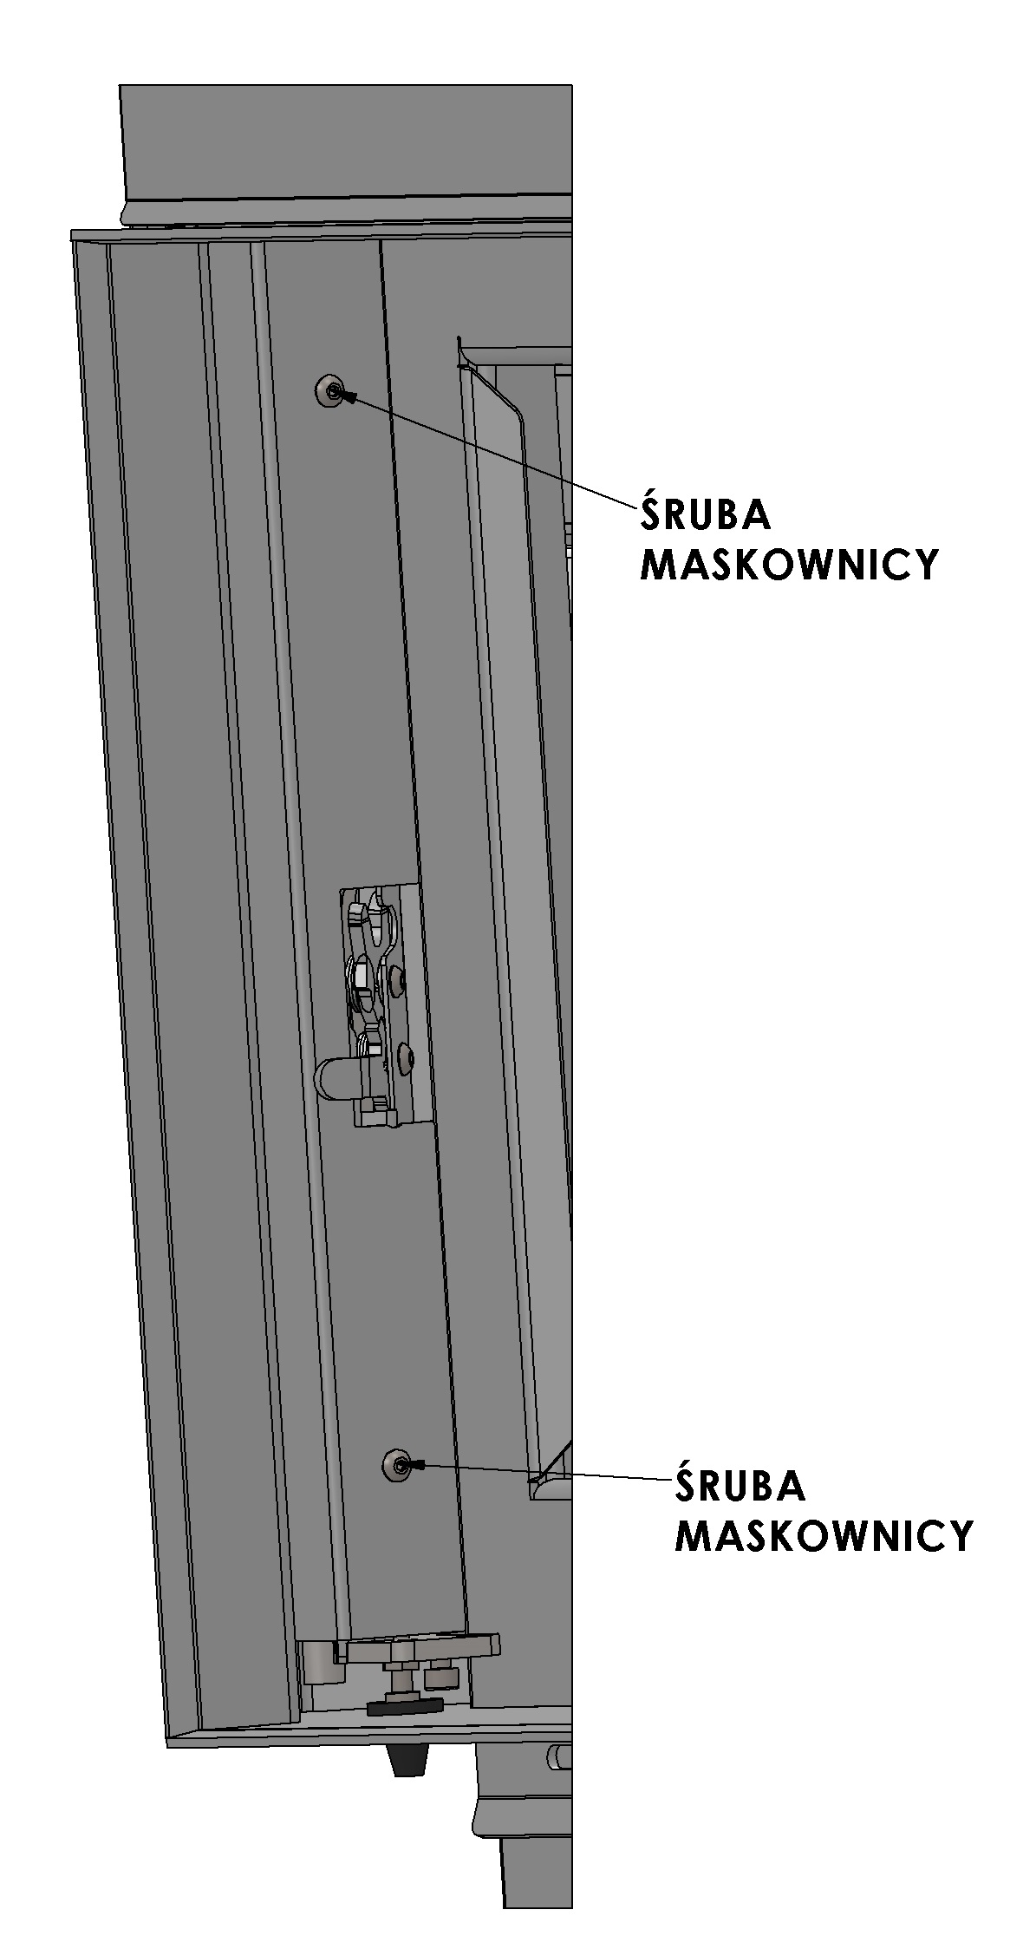screw in the masking frame.

**BEAN-HOLE ADJUSTING THE CLICK LOCK**

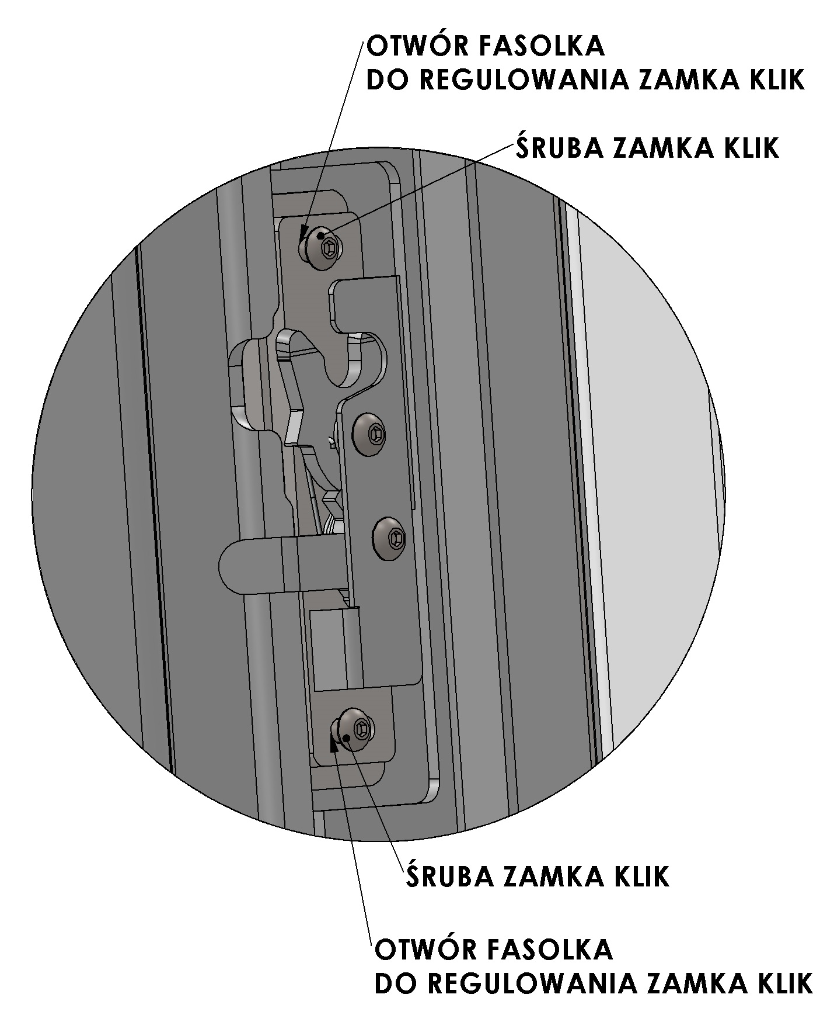

**CLICK LOCK SCREW**

**MASKING FRAME SCREW**

**CLICK LOCK SCREW**

**BEAN-HOLE ADJUSTING THE CLICK LOCK**

**MASKING FRAME SCREW**

**Figure 1. Guillotine-type door, right-sided or left-sided insert – replacement of the door lock**

**The lock in the door of horizontal and vertical inserts should be replaced as follows:**

* move the guillotine-type door to its lowest position until it touches the adjustment screws on the stopper of the sliding device;
* press down the lever protruding from the side of the wall to release the pin in the door lock (the lever is on the right or left side of the insert);
* open the door holding the handle,
* unscrew the four M5x10 screws with an Allen (hexagonal) key 3 and remove the masking frame,
* unscrew the two M5x10 screws of the click lock (using the same key as when unscrewing the masking frame),
* remove and replace the lock,
* install a new click lock – attach the M5x10 loosely,
* fasten the lateral masking frame with the remaining M5x10 screws – leave it loose for adjustment purposes,
* adjust the lock, check if the door closes – the adjustment screws can be accessed through technological holes above and below the lock (forward-backward movement in the horizontal beans);
* tighten the screws of the lock firmly as well as other screws of the masking frame.

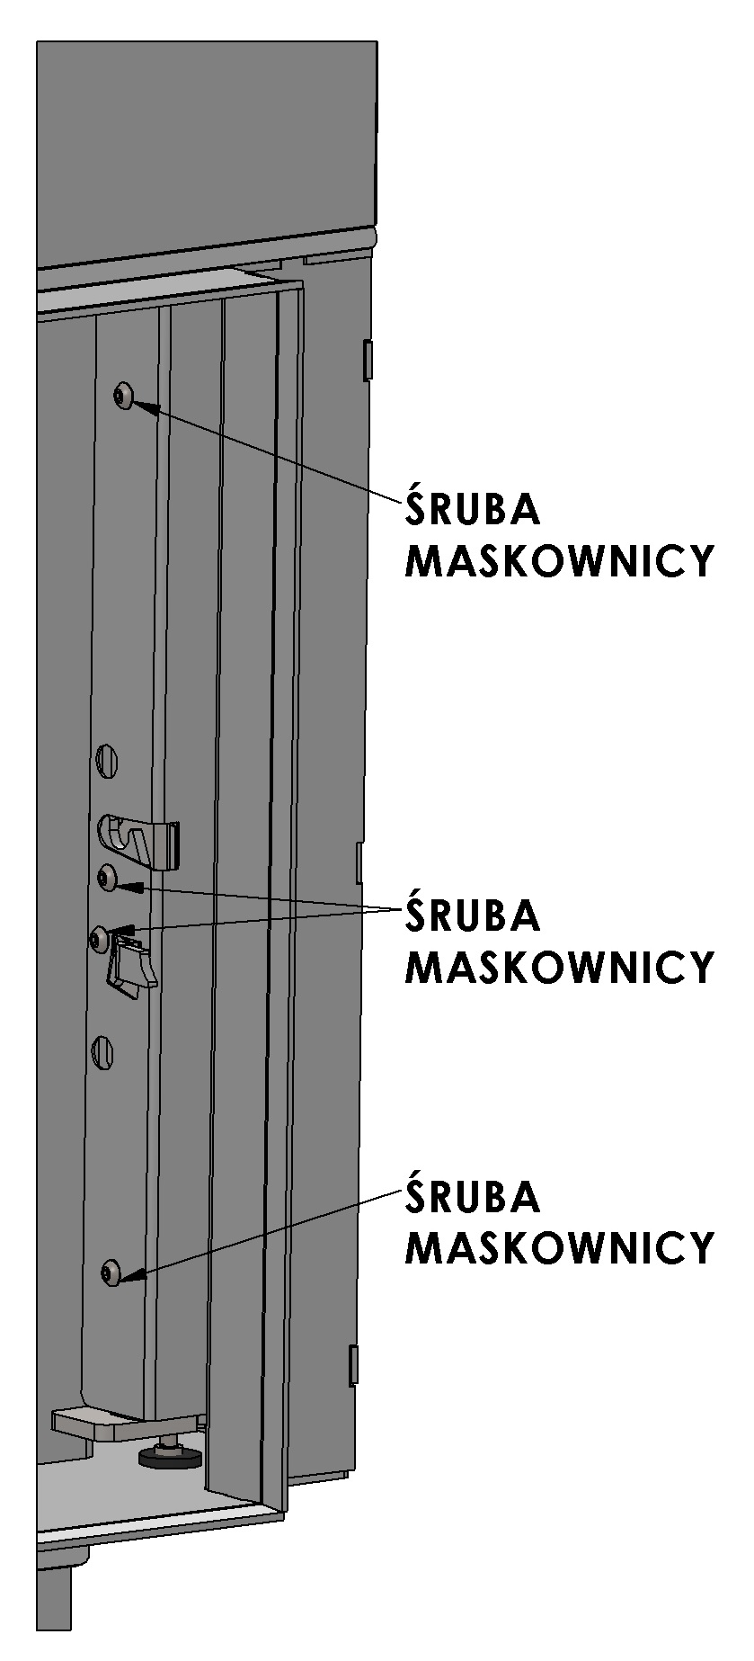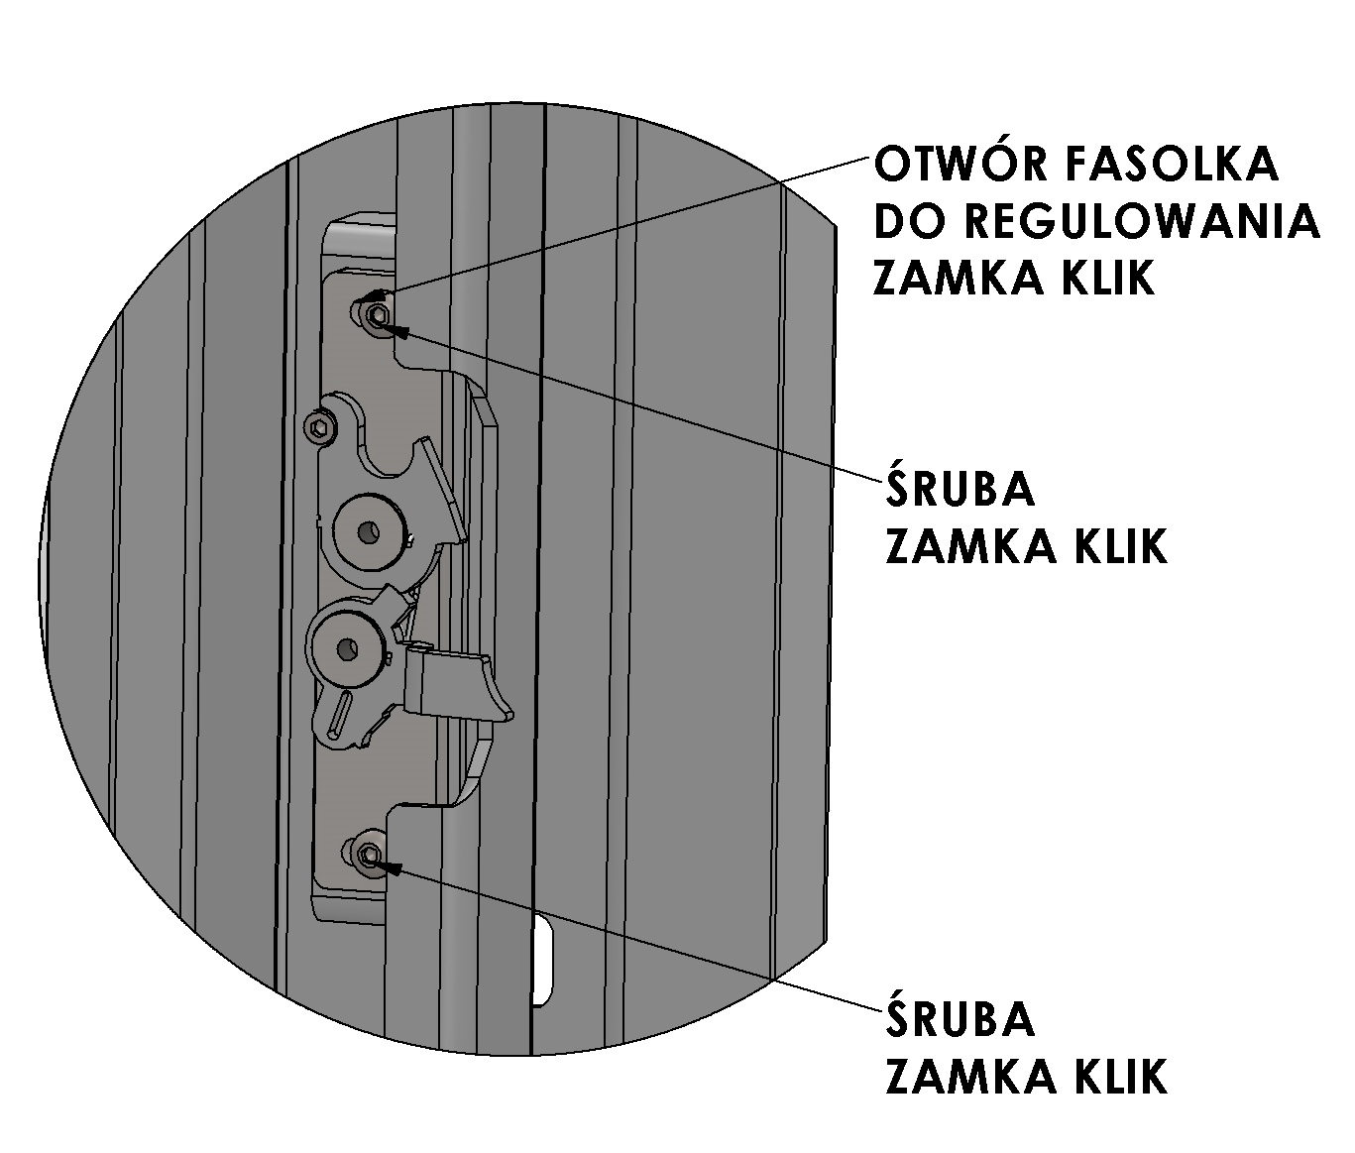

**BEAN-HOLE ADJUSTING THE CLICK LOCK**

**MASKING FRAME SCREW**

**CLICK LOCK SCREW**

**Figure 2. Guillotine-type door, horizontal or vertical insert – replacement of the door lock**

**Do not slam the door shut otherwise the glass could crack or break.**