

OPERATION AND INSTALLATION MANUAL

**FIREPLACE INSERTS**

**type: ALBERO**

Version 0.4 – 27.10.2016

**BEFORE USING THE PRODUCT FOR THE FIRST TIME, PLEASE READ THE OPERATION AND INSTALLATION MANUAL**

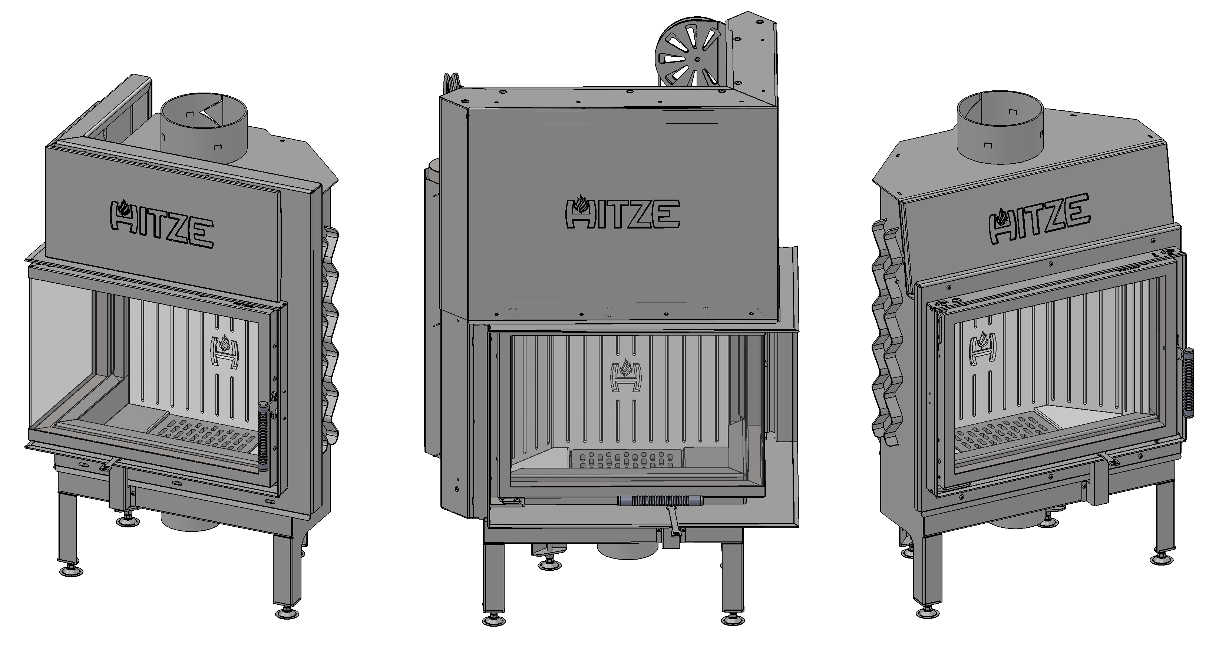

**Contents**

INTRODUCTORY INFORMATION 2

1. GENERAL INFORMATION 4
   1. Safety 4
2. INTENDED USE OF THE INSERT 5
3. TECHNICAL DATA 6
4. THE STRUCTURE AND OPERATION OF THE INSERT 21
5. THE OPENING AND CLOSING OF A GUILLOTINE-TYPE DOOR 23
6. TRANSPORT, ASSEMBLY AND INSTALLATION OF THE INSERT 24
   1. Transport 24
   2. Recommendations concerning the floor: 25
   3. Chimney duct 25
   4. Ventilation of the insert: 27
   5. Installation of the insert 28
7. START-UP 31
   1. Getting ready for the start-up 32

7.2 Lighting the fireplace 32

1. USE 34
   1. Types of fuel 34
   2. Refuelling: 34
   3. Keeping the glass pane clean 35
   4. Operation in adverse weather conditions and in the first period of use 36
   5. Removal of ash 36
   6. General comments 36
2. MAINTENANCE 38
   1. Periodic cleaning of the fireplace 38
3. TROUBLESHOOTING 39
4. NAMEPLATE 40
5. INSPECTION RECORDS 41
6. NOTES 43

INTRODUCTORY INFORMATION

Dear Customer,

Thank you for buying a product from the Hitze range!

**Heat from nature** – these words perfectly reflect the philosophy of the HITZE brand. In line with this philosophy, we produce fireplaces and stoves fired with wood or wood pellets, i.e. the raw materials which are the least harmful for the environment. Using a state-of-the-art technology, we have created innovative solutions offering modern designs and high heating efficiency.

Our products have been designed to provide you with trouble-free operation and cosy warmth!

**Before installing and connecting the fireplace insert to the heating system, it is absolutely essential to become familiar with the *Operation and Installation Manual* and to check if all components are included.**

The information contained in the *Operation and Installation Manual* is crucial for ensuring the correct functioning of the fireplace insert, and thus eliminating the risk of damage and accidents caused by improper use.

In the case of doubts or operation-related problems, please contact your point of purchase or the Manufacturer.

**NOTE:**

**This device must not be used by children.**

**Never leave your children or animals unattended when the fire is burning or when the fireplace is still hot.**

**Danger of burns (the glass and parts of the fireplace installation can be very hot).**

In order to improve the product, the Manufacturer reserves the right to make changes in drawings, photographs and descriptions or to modify the parameters of equipment without notice and at any time.

The *Operation and Installation Manual* may not be copied as a whole or in part without prior consent of the Manufacturer. Please make sure that the *Operation and Installation Manual* is stored out of reach of children.

If the *Operation and Installation Manual* is destroyed, lost or damaged, contact your point of purchase or the Manufacturer and provide the identification data of your device to obtain a replacement copy.

1. GENERAL INFORMATION
   1. Safety

Compliance with the Manual is essential for ensuring the correct functioning of the fireplace insert and avoiding damage and accidents caused by improper use.

1.1.1 Please observe the following safety rules:

* before installing the insert or performing any maintenance work on it, please make sure that you have read and understand the *Operation and Installation Manual*;
* the fireplace insert should be installed at the most convenient location and in conformity with the applicable construction and fire prevention laws;
* installation, maintenance and operation control activities may only be performed by qualified specialists;
* the device may only be used in accordance with its intended purpose;
* **it is absolutely necessary to provide the installation site with appropriate ventilation and air intake sources;**
* a clothes dryer may be placed at least 1.5 m away from the insert (to minimize the risk of a fire);
* check the permissible load carrying capacity of the substructure (floor, ceiling) at the intended location of the insert (taking into account the total weight of the insert and its encasing);
* provide an appropriate chimney installation to ensure safe operation (e.g. chimney made from non-combustible materials with poor heat-absorbing properties);
* avoid installation in rooms with B type gas devices, hoods (with or without exhaust), heat pumps, collective ventilation conduits or multiple flue pipes; the insert must not be fitted in the vicinity of the stairwell or rooms with appliances capable of creating negative pressure;
* avoid direct contact with the insert (it becomes very hot during use) and wear suitable protective equipment (protective clothing or heat-resistant gloves);
* install the insert in a room equipped with appropriate firefighting equipment and all utilities, including air, water, electricity and smoke outlets;
* if you encounter any problems, please contact your point of purchase or the Manufacturer (and always request original spare parts for repairs);
* check and periodically clean the combustion gas outlet pipe in accordance with the applicable provisions of law;
* if the device is sold or lent to another user, make sure to enclose the *Operation and Installation Manual*.

1.1.2 Never:

* lean on the fireplace insert or climb onto it;
* use the appliance in the event of fault or malfunctioning;
* place flammable materials closer than 1.5 m to the fireplace;
* light the fire with flammable materials or burn waste in the fireplace.

1.1.3 Hitze is released from civil or criminal liability in the case when:

* the insert is not used in accordance with the *Operation and Installation Manual;*
* the fireplace insert is modified or its parts are replaced with non-original parts in an authorized manner (any such modification or replacement immediately renders the guarantee null and void);
* incorrect installation or improper maintenance (non-compliant with the *Operation and Installation Manual*) lead to injuries or damage to property.

1. INTENDED USE OF THE INSERT

ALBERO fireplace inserts are intended for use as an additional source of indoor heat. They are equipped with slow-burning hearth and manual loading of fuel and are closed with a standard (hinged) door or a guillotine-type door (a pull-down door).

The inserts have been designed to be fuelled, most of all, with the wood of deciduous trees. Another acceptable type of fuel is lignite. During the burning process, thermal energy is released and transferred from the combustion chamber by conduction and radiation.

In conformity with PN-EN 13229:2002 standard, the hearth of the insert is classified as 1c, with manual loading of fuel and closed doors; It can be encased or built into a recess in the wall.

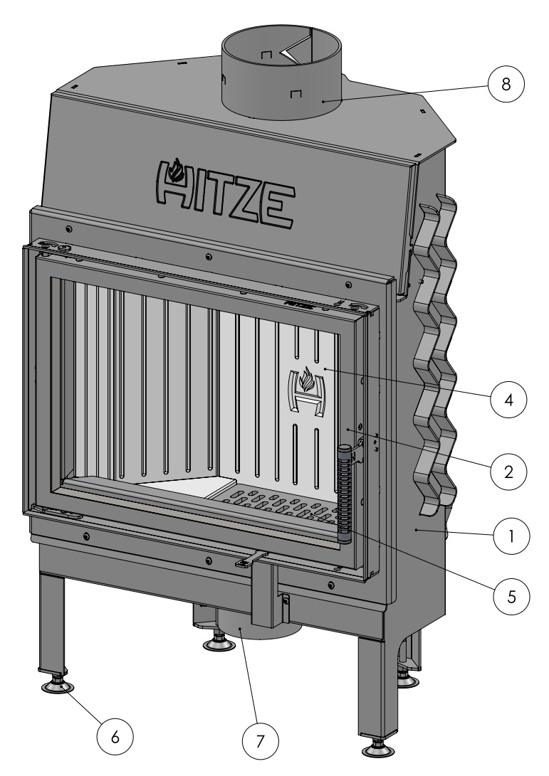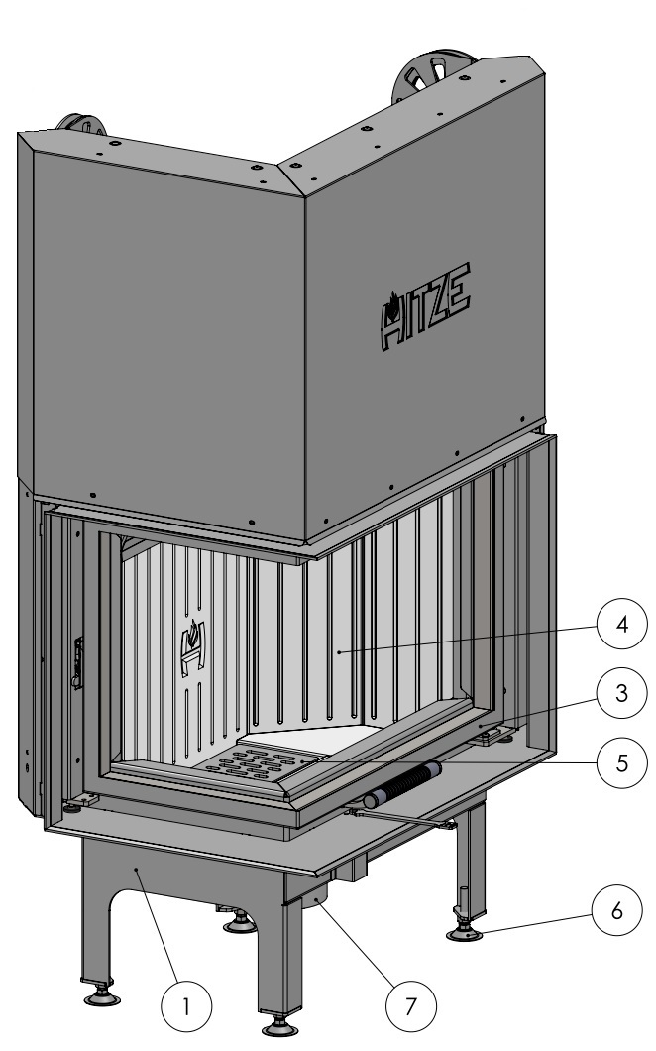

1 – shell of the insert; 2 – door-type front; 3 – guillotine-type front, 4 – akubet (a kind of chamotte) panels; 5 – grate and ash pan; 6 – regulated foot; 7 – air supply pipe, 8 – flue.

**Figure 1. ALBERO insert – with a standard door (on the left side) and a guillotine-type door**

1. TECHNICAL DATA

|  |  |  |  |  |  |  |  |  |  |  |  |  |  |  |  |  |  |  |
| --- | --- | --- | --- | --- | --- | --- | --- | --- | --- | --- | --- | --- | --- | --- | --- | --- | --- | --- |
| Fireplace insert - guillotine-type door | **AL11G.V** | 11 | 6-12 | 2.89 | 87.4 | 0.08 | 0.023 | 184 | 1000 | 800 | 200 | 125 | 590x430 | 190 | 1C | 300 ÷400 | recommended fuel: seasoned wood of deciduous trees (beech, birch, hornbeam) other permissible types of fuel: briquettes and lignite | between 12 and 20 % |
| **AL9G.V** | 9 | 5-12 | 3.09 | 78.1 | 0.082 | 0.03 | 316 | 1000 | 800 | 180 | 125 | 545x390 | 167 | 1C | 200 ÷300 |
| **AL120x43G.H** | 25 | 12-31 | 8.1 | 80 | 0.097 | 0.038 | 286 | 1000 | 800 | 250 | 150 | 1200x430 | 427 | 1C | 600 ÷900 |
| **AL19G.H** | 19 | 9-23 | 6.02 | 81.6 | 0.096 | 0.029 | 314 | 1000 | 800 | 220 | 150 | 900x415 | 258 | 1C | 600 ÷700 |
| **AL16G.H** | 16 | 8-19 | 4.15 | 81.1 | 0.063 | 0.033 | 318 | 1000 | 800 | 200 | 125 | 680x530 | 223 | 1C | 300 ÷400 |
| **AL14G.H** | 14 | 7-16 | 4.15 | 82.9 | 0.068 | 0.032 | 241 | 1000 | 800 | 200 | 125 | 680x430 | 195 | 1C | 300 ÷400 |
| **AL11G.H** | 11 | 6-13 | 3.1 | 84 | 0.099 | 0.038 | 220.5 | 1000 | 800 | 200 | 125 | 590x430 | 182 | 1C | 300 ÷400 |
| **AL9G.H** | 9 | 5-10 | 3.02 | 78.2 | 0.066 | 0.036 | 194 | 900 | 700 | 180 | 125 | 545x390 | 156 | 1C | 200 ÷300 |
| Unit | | [kW] | [kW] | [kg] | [%] | [%] | [g/m3] | [⁰C] | [cm²] | [cm²] | [mm] | [mm] | [mm] | [kg] |  | [mm] |
| Symbol | | P | Pog | B | η | CO13 | Ep | tśr | Awy | Awl | Dcz | Dd | Sz | m |  | lp |
| Parameters | | Nominal power | Heating load range | Maximum fuel load weight | Thermal efficiency | CO emission (at 13% O2) | Dust emission | Average temperature of combustion gases | Minimum active field of outlet grilles | Minimum active field of inlet grilles | Flue pipe diameter | Inlet pipe diameter | Dimension of the glass panel in the fireplace | Weight of the insert | Fireplace class | Maximum length/diameter of logs | Type of fuel | Fuel moisture content |

**Table 1. Technical data of fireplace inserts with guillotine-type doors**

|  |  |  |  |  |  |  |  |  |  |  |  |  |  |  |  |  |  |  |
| --- | --- | --- | --- | --- | --- | --- | --- | --- | --- | --- | --- | --- | --- | --- | --- | --- | --- | --- |
| Fireplace insert – guillotine-type door – right-sided and left-sided versions | **AL19LG.H**  **AL19RG.H** | 19 | 9-23 | 6.02 | 81.6 | 0.096 | 0.029 | 314 | 1000 | 800 | 220 | 125 | 900x415x375 | 273 | 1C | 600 ÷700 | recommended fuel: seasoned wood of deciduous trees (beech, birch, hornbeam) other permissible types of fuel: briquettes and lignite | between 12 and 20 % |
| **AL16LG.H**  **AL16RG.H** | 16 | 8-19 | 4.61 | 81.1 | 0.063 | 0.033 | 318 | 1000 | 800 | 200 | 125 | 680x530x375 | 220 | 1C | 300 ÷400 |
| **AL14LG.H**  **AL14RG.H** | 14 | 7-16 | 4.15 | 82.9 | 0.068 | 0.032 | 241 | 1000 | 800 | 200 | 125 | 680x430x375 | 200 | 1C | 300 ÷400 |
| **AL11LG.H**  **AL11RG.H** | 11 | 6-13 | 3.1 | 84 | 0.099 | 0.038 | 220.5 | 1000 | 800 | 200 | 125 | 590x430x375 | 186 | 1C | 300 ÷400 |
| **AL9LG.H**  **AL9RG.H** | 9 | 5-10 | 3.02 | 78.2 | 0.066 | 0.036 | 194 | 900 | 700 | 180 | 125 | 545x390x325 | 170 | 1C | 200 ÷300 |
| Unit | | [kW] | [kW] | [kg] | [%] | [%] | [g/m3] | [⁰C] | [cm²] | [cm²] | [mm] | [mm] | [mm] | [kg] |  | [mm] |
| Symbol | | P | Pog | B | η | CO13 | Ep | tśr | Awy | Awl | Dcz | Dd | Sz | m |  | lp |
| Parameters | | Nominal power | Heating load range | Maximum fuel load weight | Thermal efficiency | CO emission (at 13% O2) | Dust emission | Average temperature of combustion gases | Minimum active field of outlet grilles | Minimum active field of inlet grilles | Flue pipe diameter | Inlet pipe diameter | Dimension of the glass panel in the fireplace | Weight of the insert | Fireplace class | Maximum length/diameter of logs | Type of fuel | Fuel moisture content |

**Table 2. Technical data of fireplace inserts with guillotine-type doors – right-sided and left-sided version**

|  |  |  |  |  |  |  |  |  |  |  |  |  |  |  |  |  |  |  |
| --- | --- | --- | --- | --- | --- | --- | --- | --- | --- | --- | --- | --- | --- | --- | --- | --- | --- | --- |
| Fireplace insert - standard door | **AL14S.V** | 14 | 7-16 | 4.15 | 83.6 | 0.096 | 0.038 | 261 | 1000 | 800 | 200 | 125 | 680x430 | 148 | 1C | 300 ÷400 | recommended fuel: seasoned wood of deciduous trees (beech, birch, hornbeam) other permissible types of fuel: briquettes and lignite | between 12 and 20 % |
| **AL11S.V** | 11 | 6-12 | 2.89 | 87.4 | 0.08 | 0.023 | 184 | 1000 | 800 | 200 | 125 | 590x430 | 118 | 1C | 200 ÷300 |
| **AL9S.V** | 9 | 5-12 | 3.09 | 78.1 | 0.082 | 0.03 | 316 | 1000 | 800 | 180 | 125 | 545x390 | 105 | 1C | 600 ÷700 |
| **AL19S.H** | 19 | 9-23 | 4.61 | 81.6 | 0.096 | 0.029 | 314 | 1000 | 800 | 220 | 150 | 900x415 | 200 | 1C | 300 ÷400 |
| **AL16S.H** | 16 | 8-19 | 4.61 | 81.1 | 0.063 | 0.03 | 318 | 1000 | 800 | 200 | 125 | 680x530 | 159 | 1C | 300 ÷400 |
| **AL14S.H** | 14 | 7-16 | 4.15 | 82.9 | 0.068 | 0.032 | 241 | 1000 | 800 | 200 | 125 | 680x430 | 144 | 1C | 300 ÷400 |
| **AL11S.H** | 11 | 6-13 | 3.1 | 84 | 0.099 | 0.038 | 220.5 | 1000 | 800 | 200 | 125 | 590x430 | 131 | 1C | 200 ÷300 |
| **AL9S.H** | 9 | 5-10 | 3.02 | 78.2 | 0.066 | 0.036 | 194 | 900 | 700 | 180 | 125 | 545x390 | 102 | 1C | 600 ÷700 |
| Unit | | [kW] | [kW] | [kg] | [%] | [%] | [g/m3] | [⁰C] | [cm²] | [cm²] | [mm] | [mm] | [mm] | [kg] |  | [mm] |
| Symbol | | P | Pog | B | η | CO13 | Ep | tśr | Awy | Awl | Dcz | Dd | Sz | m |  | lp |
| Parameters | | Nominal power | Heating load range | Maximum fuel load weight | Thermal efficiency | CO emission (at 13% O2) | Dust emission | Average temperature of combustion gases | Minimum active field of outlet grilles | Minimum active field of inlet grilles | Flue pipe diameter | Inlet pipe diameter | Dimension of the glass panel in the fireplace | Weight of the insert | Fireplace class | Maximum length/diameter of logs | Type of fuel | Fuel moisture content |

**Table 3. Technical data of fireplace inserts with standard doors**

|  |  |  |  |  |  |  |  |  |  |  |  |  |  |  |  |  |  |  |
| --- | --- | --- | --- | --- | --- | --- | --- | --- | --- | --- | --- | --- | --- | --- | --- | --- | --- | --- |
| Fireplace insert – standard door – right-sided and left-sided versions | **AL19L.H**  **AL19R.H** | 19 | 9-23 | 6.02 | 81.6 | 0.096 | 0.029 | 314 | 1000 | 800 | 220 | 150 | 900x415x375 | 202 | 1C | 600 ÷700 | recommended fuel: seasoned wood of deciduous trees (beech, birch, hornbeam) other permissible types of fuel: briquettes and lignite | between 12 and 20 % |
| **AL16L.H**  **AL16R.H** | 16 | 8-19 | 4.61 | 81.1 | 0.063 | 0.033 | 318 | 1000 | 800 | 200 | 125 | 680x530x375 | 157 | 1C | 300 ÷400 |
| **AL14L.H**  **AL14R.H** | 14 | 7-16 | 4.15 | 82.9 | 0.068 | 0.032 | 241 | 1000 | 800 | 200 | 125 | 680x430x375 | 150 | 1C | 300 ÷400 |
| **AL11L.H**  **AL11R.H** | 11 | 6-13 | 3.1 | 84 | 0.099 | 0.038 | 220.5 | 1000 | 800 | 200 | 125 | 590x430x375 | 144 | 1C | 300 ÷400 |
| **AL9L.H**  **AL9R.H** | 9 | 5-10 | 3.02 | 78.2 | 0.066 | 0.036 | 194 | 900 | 700 | 180 | 125 | 545x390x325 | 109 | 1C | 200 ÷300 |
| Unit | | [kW] | [kW] | [kg] | [%] | [%] | [g/m3] | [⁰C] | [cm²] | [cm²] | [mm] | [mm] | [mm] | [kg] |  | [mm] |
| Symbol | | P | Pog | B | η | CO13 | Ep | tśr | Awy | Awl | Dcz | Dd | Sz | m |  | lp |
| Parameters | | Nominal power | Heating load range | Maximum fuel load weight | Thermal efficiency | CO emission (at 13% O2) | Dust emission | Average temperature of combustion gases | Minimum active field of outlet grilles | Minimum active field of inlet grilles | Flue pipe diameter | Inlet pipe diameter | Dimension of the glass panel in the fireplace | Weight of the insert | Fireplace class | Maximum length/diameter of logs | Type of fuel | Fuel moisture content |

**Table 4. Technical data of fireplace inserts with standard doors – right-sided and left-sided version**

|  |  |  |  |  |  |  |
| --- | --- | --- | --- | --- | --- | --- |
| **ALBERO FIREPLACE INSERTS – TYPES** | | | | | | |
| **VARIANTS** | Abbreviated name | | | | | |
| **AL9** | **AL11** | **AL14** | **AL16** | **AL19** | **AL120x43** |
| Standard horizontal S.H | AL9S.H | AL11S.H | AL14S.H | AL16S.H | AL19S.H | --- |
| Standard vertical S.V | AL9S.V | AL9S.V | AL9S.V | --- | --- | --- |
| Left horizontal L.H | AL9L.H | AL11L.H | AL14L.H | AL16L.H | AL19L.H | --- |
| Right horizontal R.H | AL9R.H | AL11R.H | AL14R.H | AL16R.H | AL19R.H | --- |
| Guillotine-type horizontal G.H | AL9G.H | AL11G.H | AL14G.H | AL16G.H | AL19G.H | AL120x43G.H |
| Guillotine-type vertical G.V | AL9G.V | AL11G.V | --- | --- | --- | --- |
| Left guillotine-type horizontal LG.H | AL9L.GH | AL11LG.H | AL14LG.H | AL16LG.H | AL19LG.H | --- |
| Right guillotine-type horizontal RG.H | AL9RG.H | AL11RG.H | AL14RG.H | AL16RG.H | AL19RG.H | --- |
| Power capacity [kW] | 9 | 11 | 14 | 16 | 19 | 25 |

**Table 5. Types of ALBERO fireplace inserts**

Full name of the insert, e.g. ALBERO AL9L.H – abbreviated name AL9L.H.

Example: AL9L.H – 9kW left horizontal ALBERO insert.

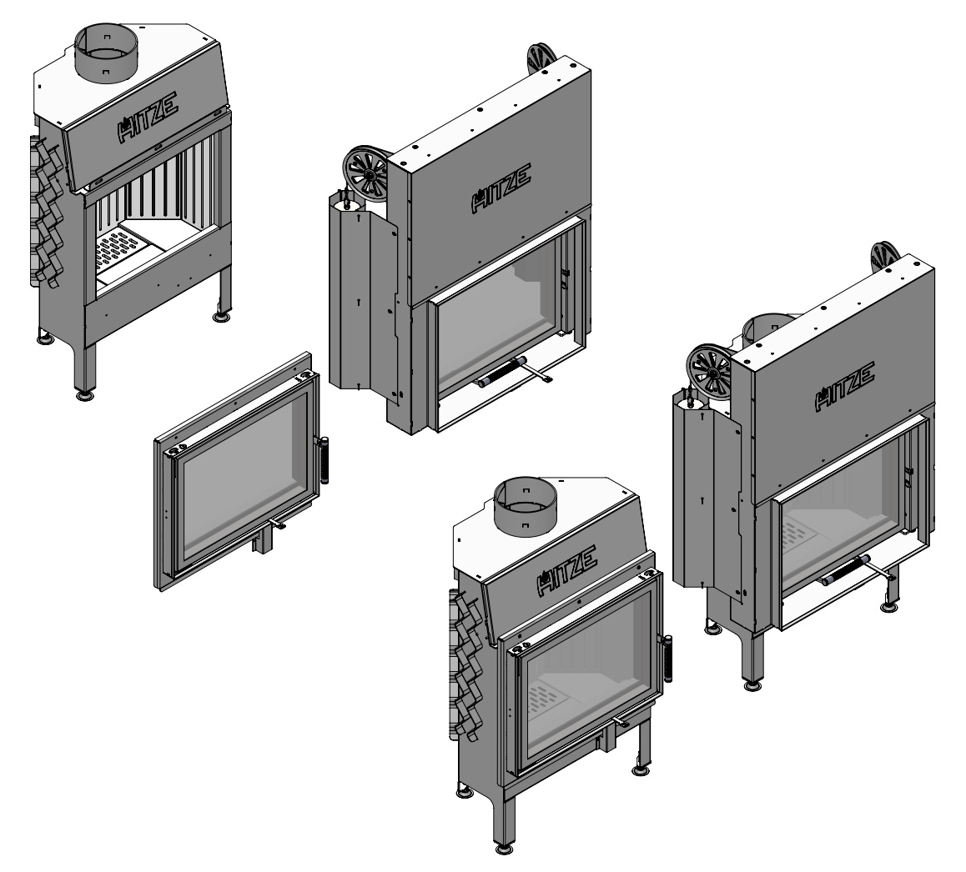

**Figure 2. Configurations of shells with the fronts of ALBERO fireplace inserts**

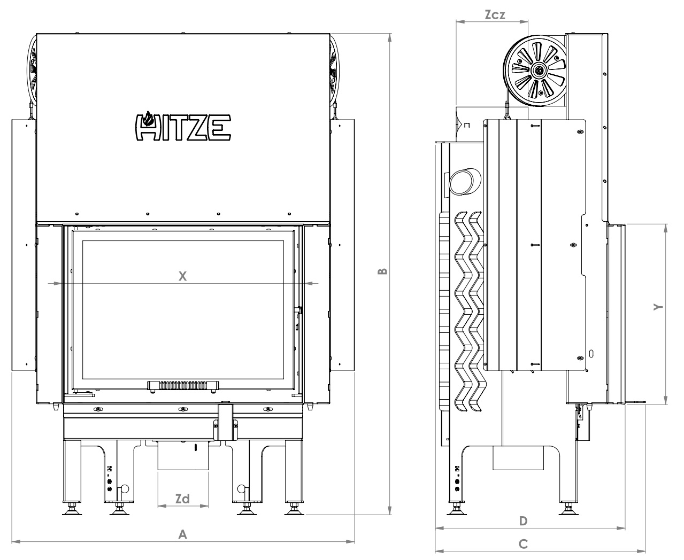

**Figure 3. Basic dimensions of fireplace inserts with guillotine-type doors**

|  |  |  |  |  |  |  |  |  |
| --- | --- | --- | --- | --- | --- | --- | --- | --- |
| Dimensions [mm] | ALBERO fireplace insert with guillotine-type doors | | | | | | | |
| **AL9G.H** | **AL11G.H** | **AL14G.H** | **AL16G.H** | **AL19G.H** | **AL120x43G.H** | **AL9G.V** | **AL11G.V** |
| A | 848 | 893 | 983 | 983 | 1203 | 1503 | 693 | 733 |
| B | 1191 | 1231 | 1231 | 1431 | 1216 | 1760 | 1461 | 1551 |
| C | 520 | 580 | 575 | 575 | 590 | 690 | 520 | 585 |
| D | 470 | 530 | 525 | 525 | 540 | 640 | 470 | 535 |
| X | 598 | 643 | 733 | 733 | 953 | 1247 | 443 | 483 |
| Y | 447 | 487 | 487 | 587 | 472 | 492 | 602 | 647 |
| Zcz | 178 | 198 | 198 | 198 | 218 | 248 | 178 | 198 |
| Zd | 125 | 125 | 125 | 125 | 147 | 147 | 125 | 125 |

**Table 6. Dimensions of ALBERO fireplace inserts with guillotine-type doors**

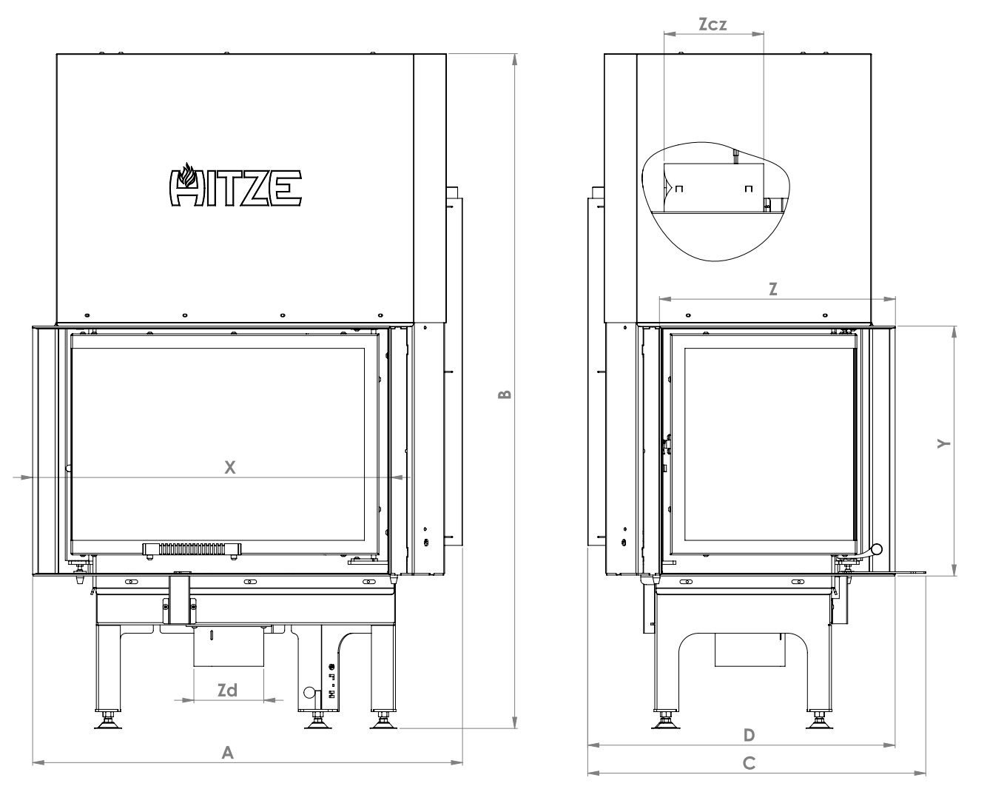

**Figure 4. Basic dimensions of fireplace inserts with guillotine-type doors (LEFT-sided)**

|  |  |  |  |  |  |
| --- | --- | --- | --- | --- | --- |
| Dimensions [mm] | ALBERO fireplace inserts with guillotine-type doors (LEFT-sided) | | | | |
| **AL9LG.H** | **AL11LG.H** | **AL14LG.H** | **AL16LG.H** | **AL19LG.H** |
| A | 769 | 814 | 904 | 904 | 1124 |
| B | 1206 | 1231 | 1231 | 1431 | 1324 |
| C | 605 | 655 | 655 | 655 | 655 |
| D | 550 | 600 | 600 | 600 | 600 |
| X | 641 | 686 | 776 | 776 | 996 |
| Y | 446 | 486 | 486 | 586 | 471 |
| Z | 423 | 472 | 472 | 472 | 472 |
| Zcz | 178 | 198 | 198 | 198 | 218 |
| Zd | 125 | 125 | 125 | 125 | 147 |

**Table 7. Dimensions of ALBERO fireplace inserts with guillotine-type doors - LEFT-sided**

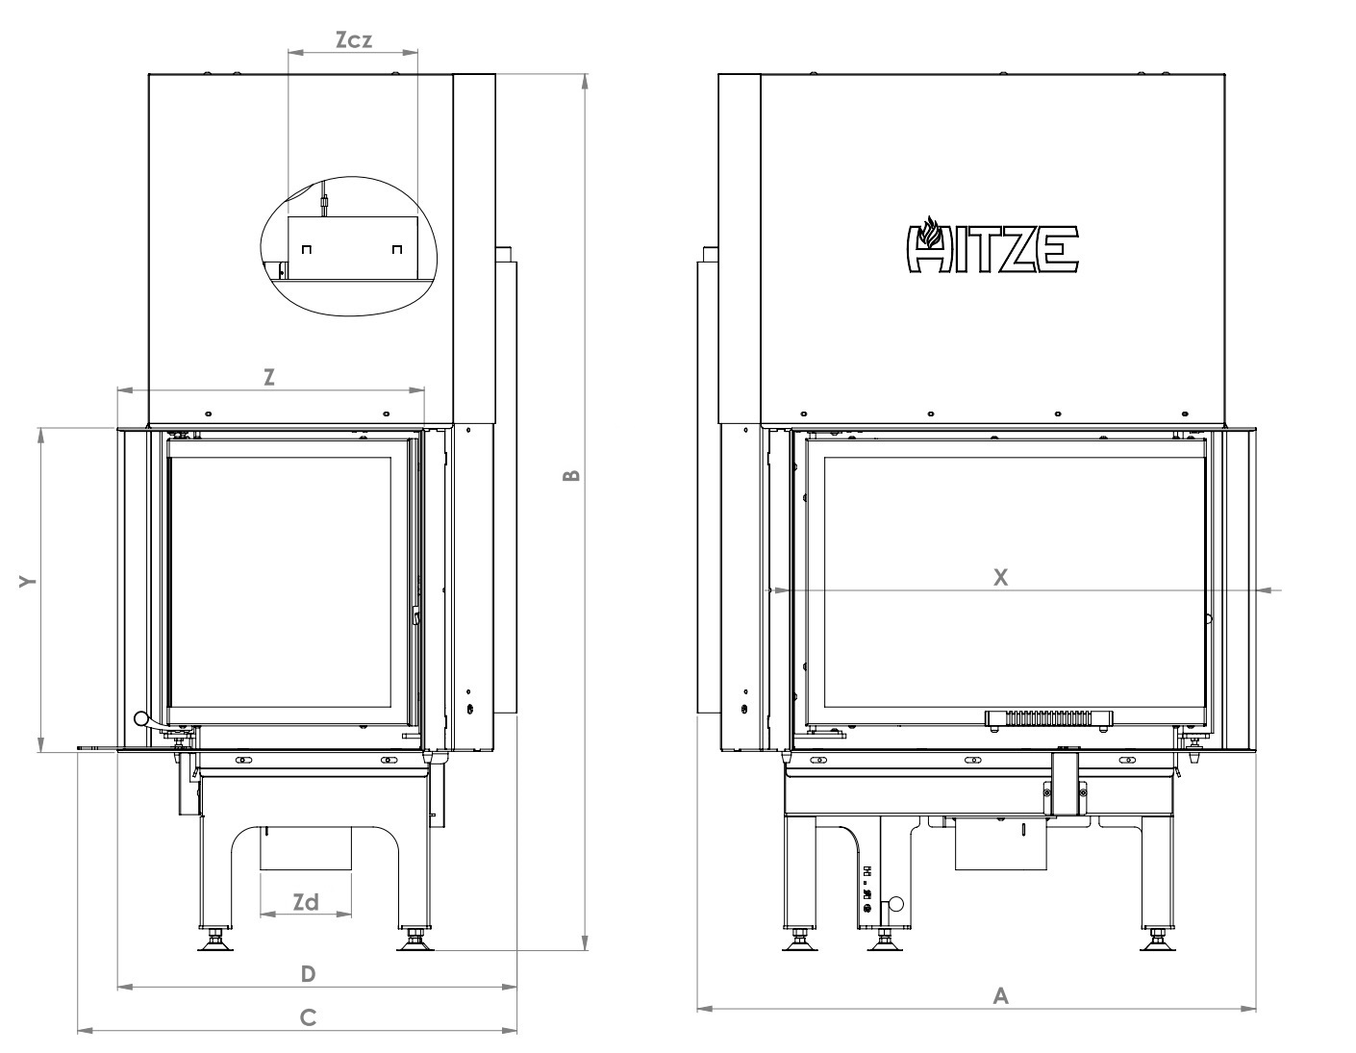

**Figure 5. Basic dimensions of fireplace inserts with guillotine-type doors (RIGHT-sided)**

|  |  |  |  |  |  |
| --- | --- | --- | --- | --- | --- |
| Dimensions [mm] | ALBERO fireplace insert with guillotine-type doors RIGHT-sided) | | | | |
| **AL9RG.H** | **AL11RG.H** | **AL14RG.H** | **AL16RG.H** | **AL19RG.H** |
| A | 769 | 814 | 904 | 904 | 1124 |
| B | 1206 | 1231 | 1231 | 1431 | 1324 |
| C | 605 | 655 | 655 | 655 | 655 |
| D | 550 | 600 | 600 | 600 | 600 |
| X | 641 | 686 | 776 | 776 | 996 |
| Y | 446 | 486 | 486 | 586 | 471 |
| Z | 423 | 472 | 472 | 472 | 472 |
| Zcz | 178 | 198 | 198 | 198 | 218 |
| Zd | 125 | 125 | 125 | 125 | 147 |

**Table 8. Dimensions of ALBERO fireplace inserts with guillotine-type doors - RIGHT-sided**

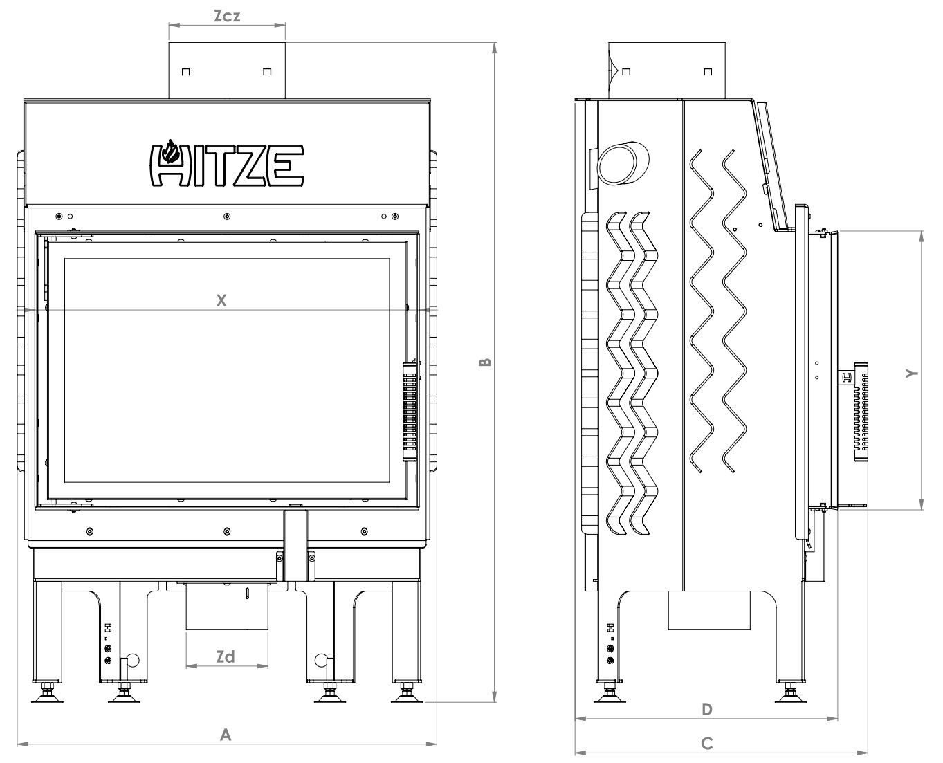

**Figure 6. Basic dimensions of fireplace inserts with standard doors**

|  |  |  |  |  |  |  |  |  |
| --- | --- | --- | --- | --- | --- | --- | --- | --- |
| Dimensions [mm] | ALBERO fireplace inserts with standard doors | | | | | | | |
| **AL9S.H** | **AL11S.H** | **AL14S.H** | **AL16S.H** | **AL19S.H** | **AL9S.V** | **AL11S.V** | **AL14S.V** |
| A | 642 | 687 | 777 | 777 | 997 | 487 | 527 | 527 |
| B | 1009 | 1049 | 1049 | 1149 | 1324 | 1164 | 1209 | 1549 |
| C | 446 | 506 | 501 | 501 | 512 | 446 | 511 | 511 |
| D | 402 | 462 | 457 | 457 | 472 | 402 | 467 | 467 |
| X | 588 | 633 | 723 | 723 | 943 | 433 | 473 | 473 |
| Y | 425 | 462 | 466 | 566 | 451 | 581 | 625 | 716 |
| Zcz | 178 | 198 | 198 | 198 | 218 | 178 | 198 | 198 |
| Zd | 125 | 125 | 125 | 125 | 147 | 125 | 125 | 125 |

**Table 9. Dimensions of ALBERO fireplace inserts with standard doors**

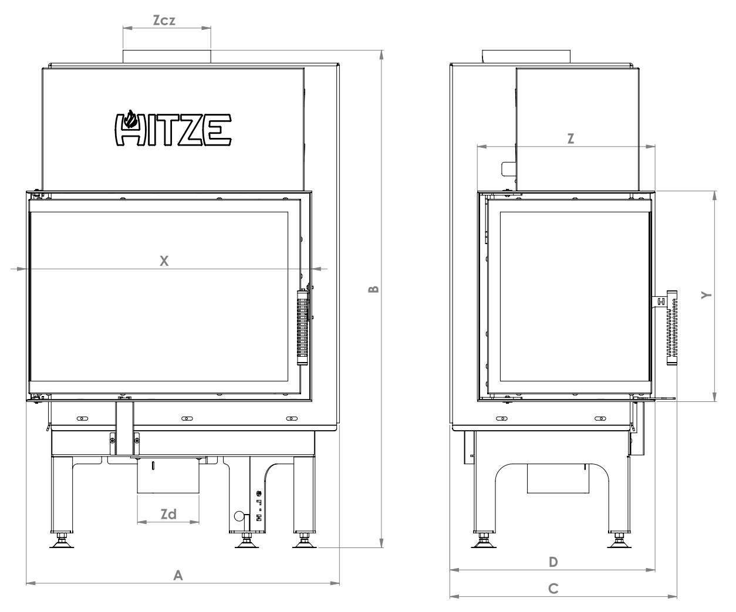

**Figure 7. Basic dimensions of fireplace inserts with standard doors (LEFT sided)**

|  |  |  |  |  |  |
| --- | --- | --- | --- | --- | --- |
| Dimensions [mm] | ALBERO fireplace inserts with standard doors (LEFT sided) | | | | |
| **AL9L.H** | **AL11L.H** | **AL14L.H** | **AL16L.H** | **AL19L.H** |
| A | 636 | 679 | 769 | 769 | 989 |
| B | 1009 | 1064 | 1065 | 1165 | 1324 |
| C | 443 | 510 | 510 | 510 | 510 |
| D | 402 | 465 | 465 | 465 | 465 |
| X | 579 | 624 | 714 | 714 | 933 |
| Y | 427 | 467 | 467 | 567 | 450 |
| Z | 359 | 410 | 409 | 409 | 409 |
| Zcz | 178 | 198 | 198 | 198 | 218 |
| Zd | 125 | 125 | 125 | 125 | 147 |

**Table 10. Dimensions of ALBERO fireplace inserts with standard doors - LEFT sided**

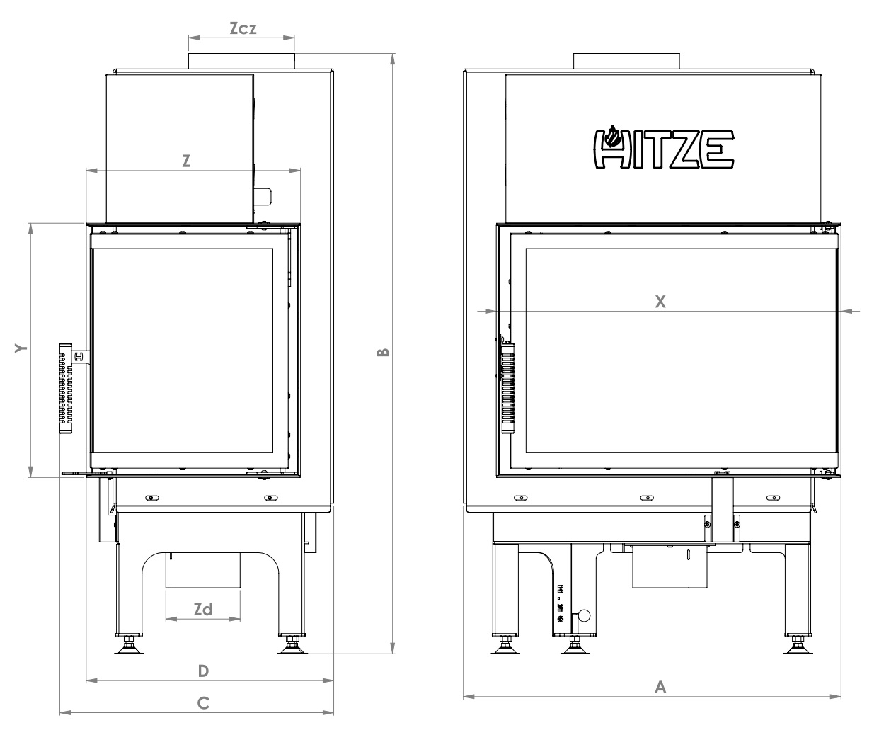

**Figure 8. Basic dimensions of fireplace inserts with standard doors (RIGHT sided)**

|  |  |  |  |  |  |
| --- | --- | --- | --- | --- | --- |
| Dimensions [mm] | ALBERO fireplace inserts with standard doors (RIGHT sided) | | | | |
| **AL9L.H** | **AL11L.H** | **AL14L.H** | **AL16L.H** | **AL19L.H** |
| A | 636 | 679 | 769 | 769 | 989 |
| B | 1009 | 1064 | 1065 | 1165 | 1324 |
| C | 443 | 510 | 510 | 510 | 510 |
| D | 402 | 465 | 465 | 465 | 465 |
| X | 579 | 624 | 714 | 714 | 933 |
| Y | 427 | 467 | 467 | 567 | 450 |
| Z | 359 | 410 | 409 | 409 | 409 |
| Zcz | 178 | 198 | 198 | 198 | 218 |
| Zd | 125 | 125 | 125 | 125 | 147 |

**Table 11. Dimensions of ALBERO fireplace inserts with standard doors - RIGHT sided**

1. THE STRUCTURE AND OPERATION OF THE INSERT

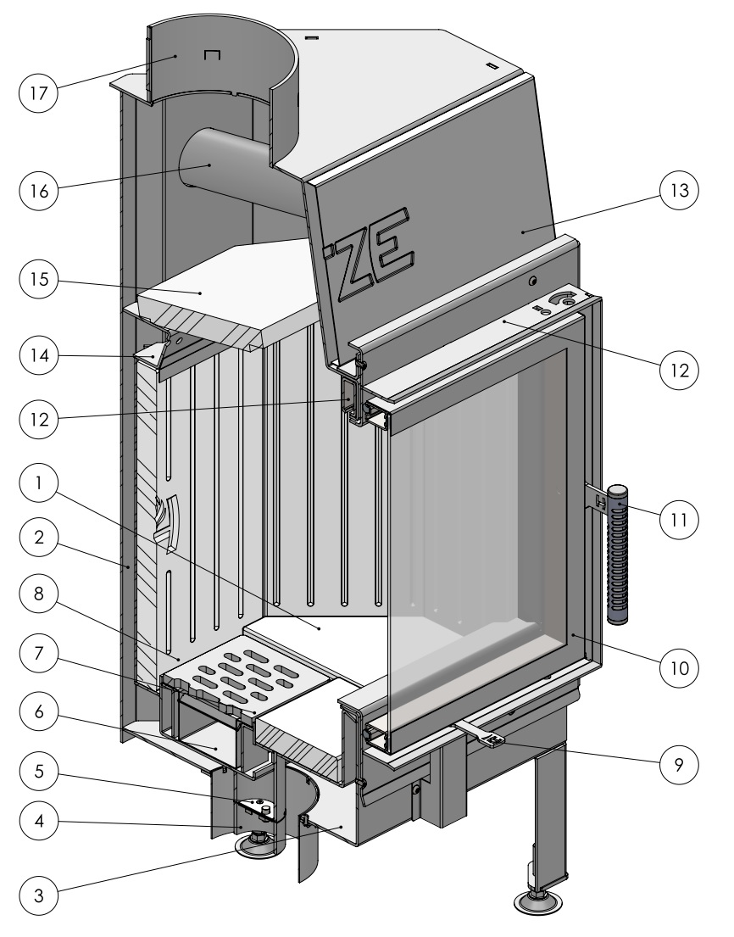

**Figure 9. General structure of the ALBERO insert**

The fireplace insert consists of a body **2** and of a front **10**. The body (shell) is made from P265GH boiler steel with a thickness of 3mm.

The front panel consists of a steel door made from a special profile and profiled steel sheet metal, heat-resistant glass and a handle **11**. The handle has been specially designed to remain cool when the fireplace burns. The door is screwed to the bars **12**, which are fastened to the body of the insert.

The front is available in two options. The first one is a hinged door opening to the right or left, the second one is a guillotine-type door which can be lifted upwards.

The bottom of the combustion chamber **1**, its side walls and the back wall are lined with akubet (a kind of chamotte) **8**. It has a double floor **3** with primary and secondary air inlets, as well as an ash pan **6** and a grate **7**. Air inlet **4** is provided through a connection pipe with a diameter of 125mm, which incorporates an additional connection pipe with a diameter of 60mm, and a mechanism regulating the flow of air – throttle **5**. With such a solution, the insert needs only one pipe for supplying air from outside.

The throttle is regulated with a lever **9** installed under the front panel. The throttle is regulated by turning the lever to the right or to the left. When the lever is placed in its rightmost position, the inflow of air is cut off. The maximum inflow of air can be ensured by moving the lever to its leftmost position.

After passing through the throttle, the air finds its way to the ash pan **6** and then to the grate **7.** The air is directed to the combustion chamber through slots in the grate.

Secondary air enters the combustion chamber through the combustion gas after-burning system **14**, i.e. through apertures in the rear top part of the shell and through apertures made in the chamotte (akubet) lining (in some insert models). The insert is also equipped with an air curtain which reduces soot deposition on the glass pane, which ensures a “clean glass” effect.

Above the combustion chamber, there is a special akubet plate called a deflector **15**. Some insert models have two deflectors.

The decorative masking frame **13** should be removed during the installation of the fireplace insulation (the masking frame is a non-detachable part and has a guillotine-type door, like the insert itself). Radiators (pipes) **16** are welded to the body of the insert. The radiators and the deflector form a convection channel, which optimizes the heat exchange. During the burning process, combustion gases float around the walls of the combustion chamber, the deflector and the horizontal radiators. Then they pass through the flue **19** and the ducts and finally reach the chimney.

The air surrounding the encased insert is heated (by convection) and escapes into the room through appropriate ventilation slots in the encasing of the fireplace. This ensures heat recovery and provides an additional source of indoor heating.

1. THE OPENING AND CLOSING OF A GUILLOTINE-TYPE DOOR

A guillotine-type door can be moved up or down. It also opens sideways.

**To open the door sideways** (e.g. for the purpose of cleaning the insert after use), do the following:

* in the case of a guillotine-type door, move the door to its lowest position until it touches the adjustment screws on the stopper of the sliding device;
* press down the lever protruding from the side of the wall to release the pin in the door lock (the lever is on the right or left side of the insert);
* open the door holding the handle;

after opening the door, perform maintenance activities or clean the insert.

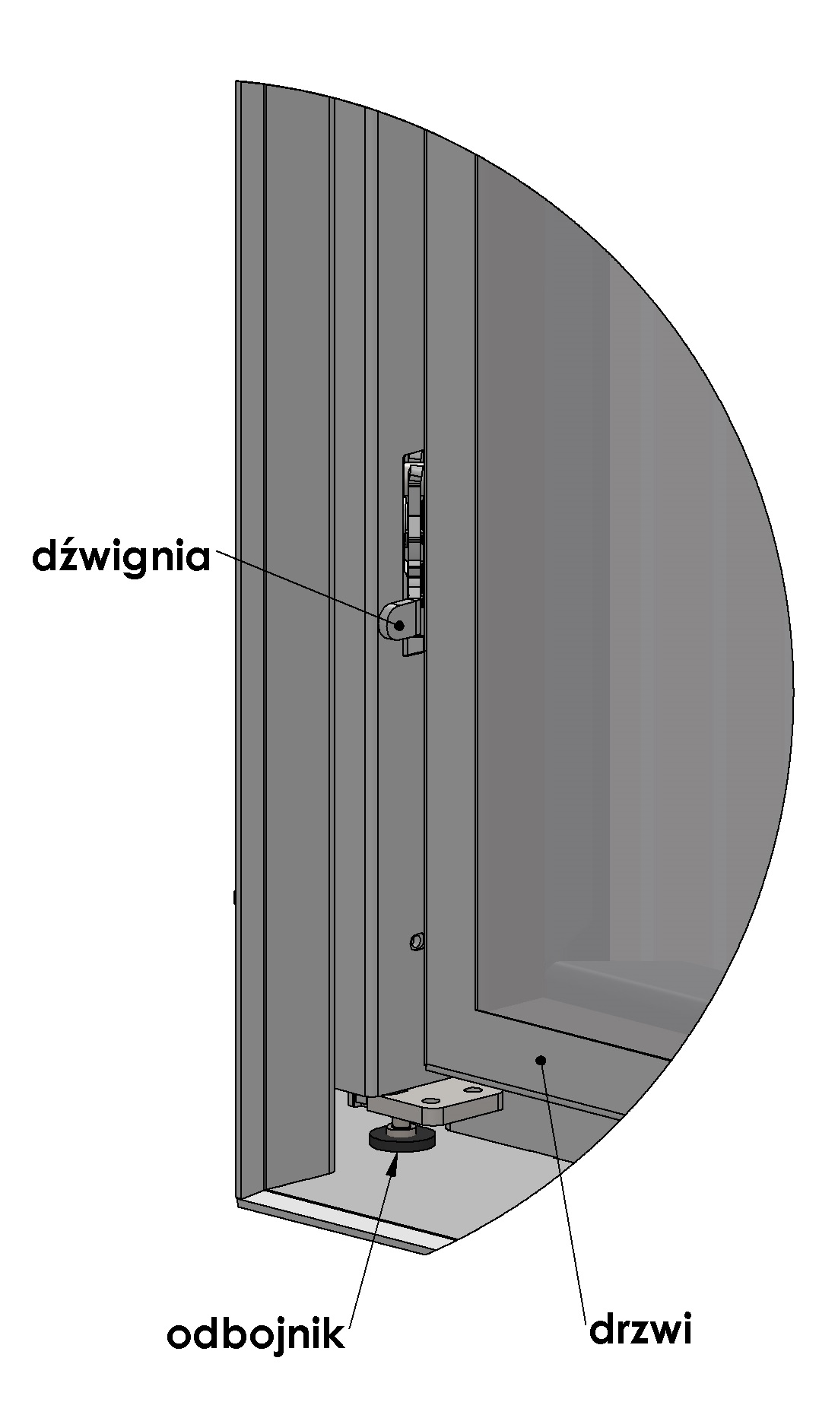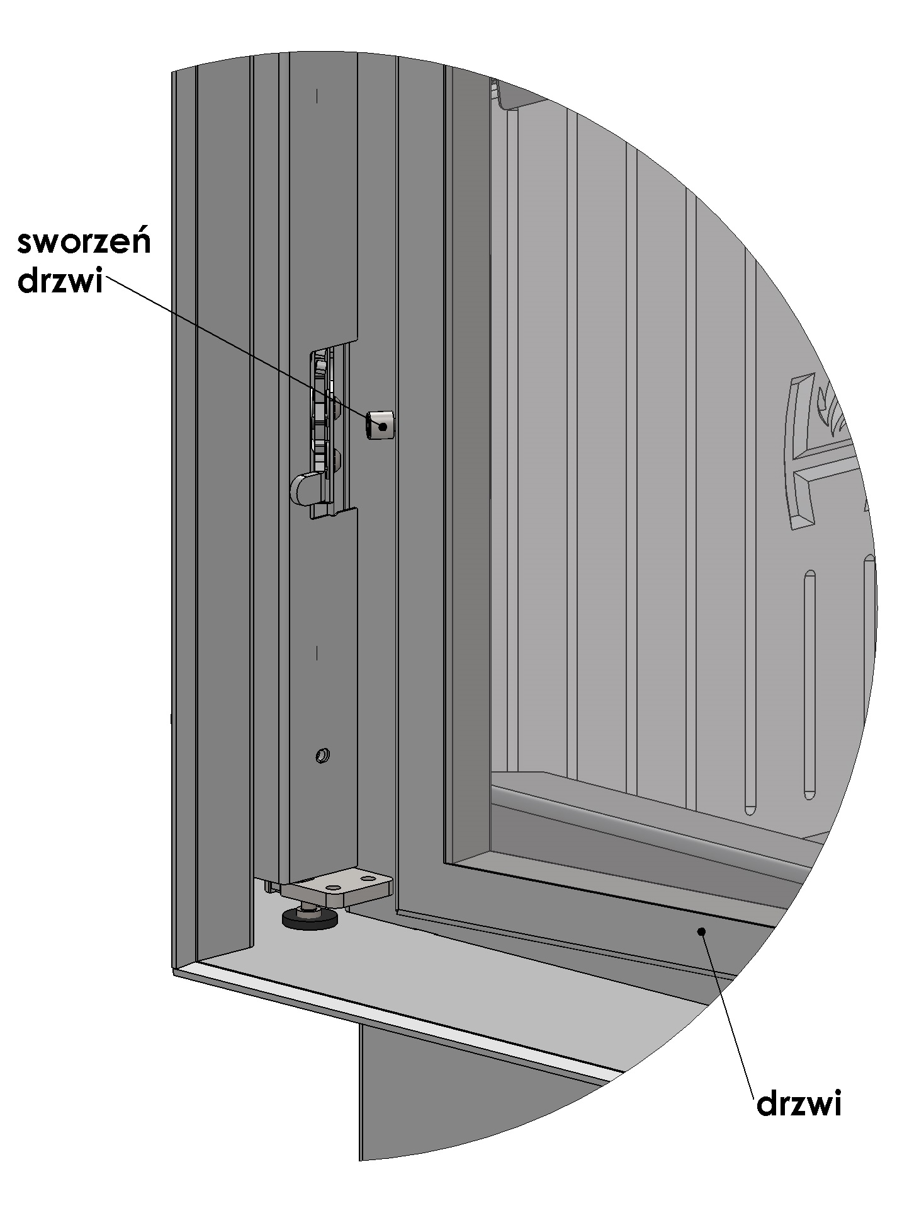

**door pin**

**lever**

**door**

**door**

**stopper**

**Figure 1. Guillotine-type door – the opening and closing of the door**

**The door of the insert** is closed in the following way:

* by performing a swinging movement and pressing the door down - the pin will click into its place in the lock, then lift the door upwards, simultaneously pressing it down (until you hear a characteristic clicking sound). Hold the handle when lifting the door.

**Do not slam the door shut otherwise the glass could crack or break.**

1. TRANSPORT, ASSEMBLY AND INSTALLATION OF THE INSERT

The device is compliant with the PN-EN 13229:2002 standard and has a CE certificate.

**Before assembling, installing and using the fireplace insert, read the *Operation and Installation Manual* carefully and follow the instructions contained in it. It will ensure safe and efficient operation of the fireplace. Non-compliance with this *Operation and Installation Manual* may invalidate the guarantee and put the user at risk of injury or loss of life.**

The product must be assembled, installed and used in accordance with the national and local laws and standards, including in particular:

* Regulation of the Minister of Infrastructure of 12.04.2002 Dz.U. [Polish Journal of Laws] No. 75, item 690 amended on 07.05.2004 Dz.U. [Polish Journal of Laws] No. 109, item 1156;
* PN - B – 03406 Standard: 1994 Heating engineering. Calculated heat demand;
* PN – 89 / B – 10425 Standard: Flue pipes, combustion gas ducts and ventilation ducts made from bricks;
* PN – 78 / B – 03421 Standard: Ventilation and air conditioning. Parameters for calculating indoor air;
* PN-EN 13229:2002 Standard “Inset appliances including open fires fired by solid fuels. Requirements and test methods”.

**The fireplace insert must be installed by a qualified person or company and commissioning checks must be performed by a master chimney sweep and a fire prevention specialist.**

The installation of the fireplace should be performed in the following order:

* connection of the fireplace to the chimney and assembly of the air intake;
* putting the fireplace into use and observing its functioning for the purpose of detecting defects and anomalies (for about 2 weeks);
* assembly of the encasing.
  1. Transport

**Transport and handling:**

* the insert is delivered as an assembled unit, fastened to a palette and wrapped in stretch foil;
* the fireplace should be transported in a vertical position;
* after unpacking, check the insert for any transport related damage;
* unpack the insert in the vicinity of the installation site; exercise caution when moving the insert (preferably on a cart) (paying special attention to the door and glass);
* the packaging materials of the fireplace insert are not toxic or harmful and should be recycled or stored by the User;
* to facilitate the assembly of the fireplace in hard-to-reach places, the akubet (chamotte) lining (shielding the hearth) can be removed; after the assembly, every akubet element should be correctly placed in its intended location.
  1. Recommendations concerning the floor:
* before installing the fireplace insert, check the load-bearing capacity of the floor (to make sure that it is sufficient to bear the weight of a given type of appliance);
* the floor must be made of non-flammable material with a minimum thickness of 30 cm; a safety area of least 50 cm must be ensured in front of the fireplace door, and of at least 30 cm from the edges of the door.
  1. Chimney duct

The fireplace insert must be appropriately selected to match the cross section of the combustion gas duct (flue pipe) and the height of the flue.

The cross-sectional area of the flue and of the combustion gas duct is calculated in accordance with the following formula:



where:

F – cross-sectional area of the flue and of the combustion gas duct [m2];

Q – rated thermal input [kW];

h – the height of the chimney [m].

In accordance with the applicable provisions of law, the flue may not be smaller than 14x14cm or its diameter must be 15cm. Inserts with a higher thermal input require a flue with a larger cross section. The cross section also depends on the height of the chimney.

**The fireplace should be connected to the combustion gas duct or the vertical duct in accordance with the applicable national standards.**

The chimney draught should be as follows:

**-** minimum draught – 6 ± 2 Pa;

**- MEDIUM, RECOMMENDED DRAUGHT – 12** ± **2 Pa;**

**-** maximum draught – 15 ± 2 Pa.

**NOTE:**

**To ensure the correct functioning of the insert, there must be a correct chimney draught in the connector of the flue pipe:**

* **the insert will not function properly if the chimney draught is not sufficient, resulting in excessive soot deposits on the glass and in combustion gas ducts and reducing the total thermal power of the insert (due to which combustion gases may escape to the room);**
* **if the draught is too strong, the burning process may be too intense, causing high consumption of fuel and resulting in permanent damage of the insert.**

**The chimney should be regularly inspected by a chimney sweep company.**

6.3.1 Connection to the chimney ducts:

* before installing the fireplace insert, the chimney ducts and its technical parameters and condition must be inspected and approved by a chimney expert;
* the fireplace insert may only be installed after the flue pipe has been inspected and approved by a chimney expert.

The chimney duct must satisfy the applicable national or European standards.

The fireplace insert must be mounted and connected to the chimney in accordance with the supplied *Operation and Installation Manual* (together with deflector plates - if they are to be used, and the insulation of the flue pipe).

The manufacturer **does not recommend** the assembly and installation of the appliance by the user on his or her own. To make sure that the insert is installed and put to use in a correct and safe manner and to satisfy the guarantee conditions, the user should have the appliance installed and put to use by a qualified installer or an installation company. The installer is required to confirm in the guarantee card (signature and stamp) that the fireplace has been installed in accordance with good building practices and the applicable legal provisions. If the above-mentioned activities are not performed, it will invalidate the guarantee.

6.3.2 The combustion gas outlet system should have the following features:

* the cross section of the flue pipe may not be smaller than the cross section of the chimney duct and it may not become narrow towards the chimney (between the flue pipe and the chimney, the diameter can be increased through the use of mounting adapters);
* the path of the combustion gas duct should be as short and straight as possible (bends increase flow resistance and facilitate the accumulation of condensed moisture);
* it is forbidden to connect the insert to the same chimney duct with another heating device;
* the fireplace insert should be connected to its own chimney duct;
* the combustion gas duct may not have more than two inclinations of 45° when its length does not exceed 5 m and of 20° when it is more than 5 m long;
* the combustion gas duct must be made from non-combustible materials and it must be thermally insulated;
* the insulation of the flue pipe must ensure fire resistance for at least 60 minutes;
* the flue exit should be followed by a straight pipe with a minimum length twice as long as the diameter of the fireplace flue;
* the connector must be leak-proof;
* the end of the chimney should ensure a trouble-free outlet for combustion gases and it should be placed at least 60 cm above the highest point of the roof;
* the connectors must be made from stainless, heat-resistant steel 1.4401 (316) or fireplace steel, painted with a special paint. The metal sheet must have an appropriate thickness (heat-resistant and stainless steel must be 1mm thick, fireplace steel - 2mm) and be resistant to high temperature, the acidity of combustion gases and condensed moisture.

**Enough room should be left when building the enclosure of the fireplace insert so as to ensure an easy access for the purpose of cleaning the insert, the flue pipe and the chimney.**

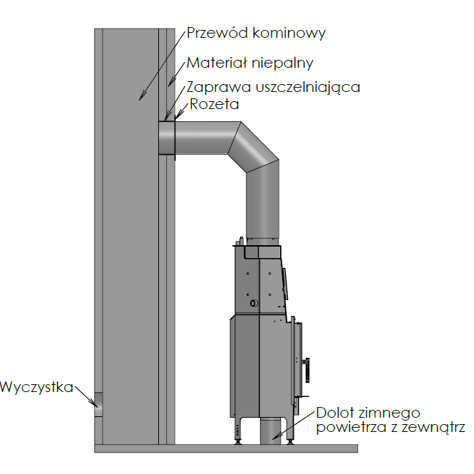

Chimney duct

Non-flammable material

Sealing mortar

Rosette

Inflow of cold air from outside

Cleaning hole

**Figure 10. The scheme of connection of the insert to the chimney duct**

* 1. Ventilation of the insert:
* fresh air **must** be supplied to the combustion chamber **from outside** (if the amount of air is too small, it will hinder the burning process and toxic combustion gases may be produced, including carbon monoxide);
* the fireplace must be encased in such a way so as to ensure a supply of fresh air from outside (by using an air inlet pipe with a diameter of 100¸160mm);
* it is estimated that about 8m³ of air is required for burning 1kg of wood;
* in the case of using a system of distributing air to other rooms, it is essential to ensure the return of cooled air to the room where the fireplace insert is installed so that the air can circulate freely (otherwise, the work cycle of the fireplace insert may become disrupted, which will hinder the distribution of warm air);
* when choosing the site for the appliance and during its installation, attention should be paid to ensuring the correct circulation of air and a proper balance between air inflow and outflow in the room;
* ventilation must be provided in the room where the fireplace is installed;
* the ventilation of the insert should have a cold air inlet and a warm air outlet (ventilation should be provided for the convection space to make sure that air comes into contact with the heatable parts of the insert and enters the flue pipe).
  1. Installation of the insert

The appliance must be installed in accordance with the applicable provisions of the building law.

**The fireplace must be installed and assembled by qualified specialists.**

6.5.1 To ensure the correct installation:

* the insert must be placed at a safe distance from any flammable materials (the walls or other surfaces surrounding the fireplace may have to be secured);
* the encasing should ensure easy access to regulation handles and operating buttons (it should be possible to assemble and disassemble the insert without having to dismantle and damage the encasing);
* it is forbidden to install the insert in a bedroom, bathroom or in a room with another heating device without its own air intake;
* it is not permitted to integrate the insert with an air recuperation system;
* ALBERO inserts are standalone devices and do not require any additional supports;
* the fireplace is equipped with regulated feet for adjusting the height (levelling) the fireplace (with an adjustment range of up to 4 cm);
* if the fireplace has to be raised above the adjustment range of the feet, make a brick base and place the fireplace on it (do not remove the feet as they are needed for levelling purposes);
* incorrect levelling of the fireplace will hinder the functioning of the door (it will not close properly);
* **inlet grille (inspection window) at the front or on the side, in the lower part of the encasing - should ensure an easy access to the throttle mechanism at the front or from underneath the insert.**

6.5.2 General recommendations concerning the encasing:

* the fireplace insert can be placed anywhere, as long as it is positioned at an appropriate distance from the insulation and the encasing;
* the supporting structure and the encasing of the fireplace insert must be made from

non-flammable heat-resistant materials ;

* the encasing should be made from non-flammable materials;
* a distance of at least 10 cm must be maintained between the insulation materials and the insert;
* there should be a warm air outlet grille in the encasing, positioned 80cm from the ceiling (in the case of flammable materials);
* during normal use, the encasing of the fireplace extends when heated, therefore there should be tiny gaps between stone, marble or ceramic elements;
* preferably, the insulation material should be resistant to temperatures of over 500⁰C;
* preferably, no insulation should be provided for the flue (it will ensure more effective dissipation of heat into the room);
* the encasing may not lean on the fireplace;
* the thickness of the insulation depends on the thermal conductivity coefficient λ (the ability of a material to conduct heat) and heat resistance of a given material;
* in the encasing of the insert, there should be a cold air inlet grille (at the bottom of the encasing) and a warm air outlet grille.

The λ coefficient is specified by the manufacturer of the insulation, e.g. for mineral wool it is 0.035-0.045.

The lower the λ coefficient, the better the insulation (“thermal insulation in the room”).

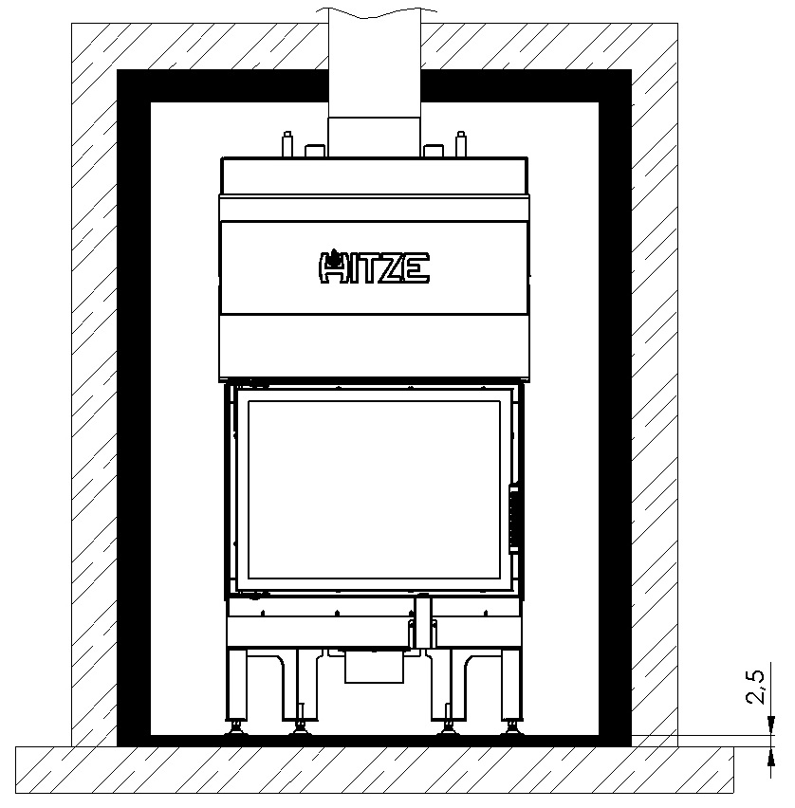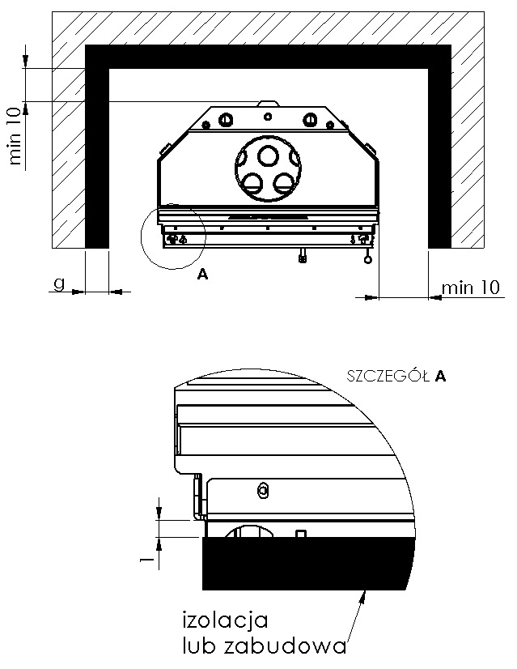

throttle mechanism

**Figure 11. A standard encasing (all dimensions in the figure are given in [cm])**

The thickness of the insulation is calculated in accordance with the formula:



where:

g – thickness of the insulation (partition) [m];

λ – thermal conductivity coefficient [W/m·K];

R – coefficient of thermal resistance of a layer of material [m²·K/W].

For materials with thermal resistance of , with λ=0,035 and R=2, the thickness of the insulation layer is 0.07m i.e. 7cm.

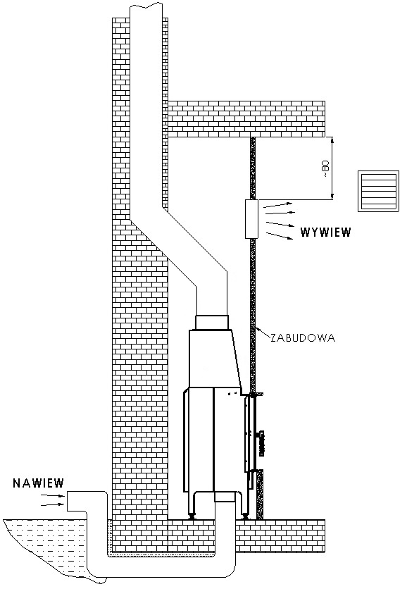

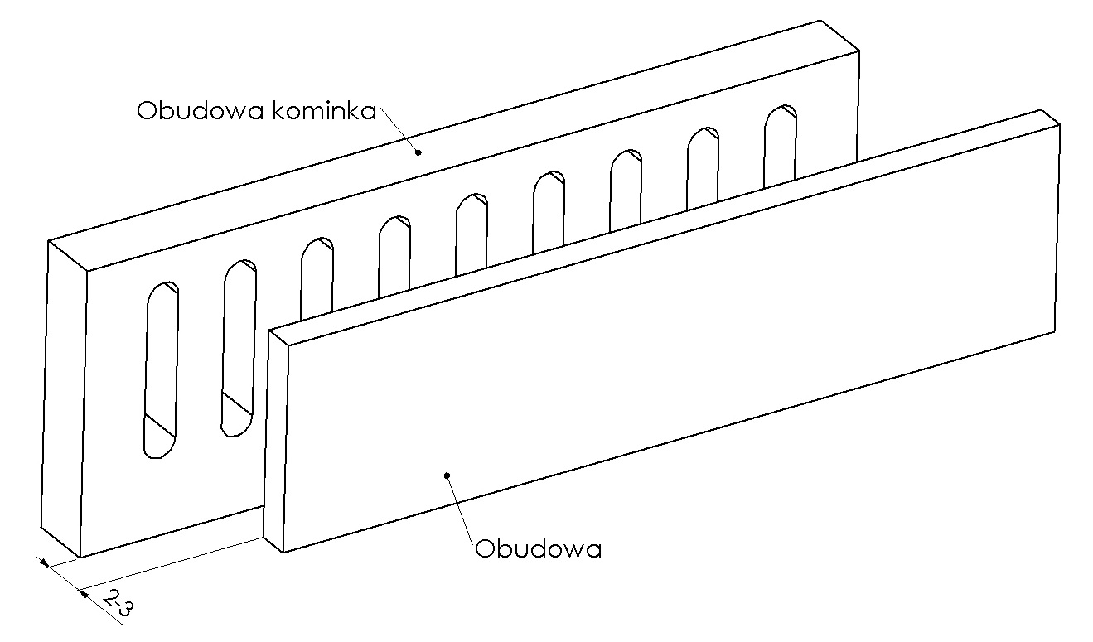

Fireplace surround

AIR OUTLET

ENCASING

Surround

Throttle mechanism

AIR INLET

**Figure 12. The recommended method of installing the insert**

The areas of the inlet and outlet grilles depend on the power output of the fireplace, the size of the room and its cubic volume.

The height of the room 2.5m.

|  |  |  |  |  |
| --- | --- | --- | --- | --- |
| Heat output of the fireplace [kW] | Minimum area of the room [m²] | Minimum cubic volume of the room [m³] | The area of the inlet grille [cm²] | The area of the outlet grille [cm²] |
| 7 | 35 | 88 | 700 | 900 |
| 9 | 45 | 113 | 700 | 900 |
| 11 | 55 | 138 | 800 | 1000 |
| 14 | 70 | 175 | 800 | 1000 |
| 16 | 80 | 200 | 800 | 1000 |
| 19 | 95 | 238 | 800 | 1000 |
| 25 | 125 | 313 | 800 | 1000 |

**Table 12. The areas of the inlet and outlet grilles in the encasing of the fireplace**

1. START-UP

After the fireplace insert has been mounted and connected to the chimney, the first start-up of the fireplace must be performed by an installer or a qualified service technician.

As part of the start-up procedure, the installer should show the User how to operate the fireplace correctly.

The installer is obliged to refuse to put the fireplace into use if he or she finds any assembly-related irregularities which make it unsafe to use.

A correctly performed start-up should be confirmed in writing in the guarantee card.

* 1. Getting ready for the start-up

Before lighting the fireplace for the first time, it is necessary:

* to remove any labels, paper stickers and accessories from the body of the shell, ash pan or hearth to eliminate the risk of fire; the same applies to transport safety devices;
* to check if the deflector/s, akubet fittings and the grate are mounted correctly and were not dislodged from their correct position during installation (any discovered mounting errors must be corrected). Non-removal of such errors may hinder proper functioning of the fireplace insert. In the case of inserts with multi-pane glass doors, it should be checked if particular glass panes did not become loose during transport or use;
* to check the operation of:
* mechanism regulating the inflow of air into the combustion chamber (cold air inflow throttle);
* front door closing mechanism (hinges, handle);
* to check if the hydraulic system has been installed correctly and in accordance with this *Operation and Installation Manual* and the applicable legal provisions, especially in terms of the following safety-related issues:
* has the fireplace has been levelled?
* has a proper ventilation system been provided for the room and the fireplace?
* does the air intake ensure unobstructed flow of air from outside and into the room?
* is the connection to the chimney sealed properly?
* has the fireplace surround been built correctly?

7.2 Lighting the fireplace

Before lighting the fireplace, please do the following:

* arrange a stack of firewood in the hearth, starting with larger pieces of wood, followed by medium-sized pieces of wood and then by small chips of wood for fire lighting – light it with a match;
* set the primary air regulator in the fully open position;
* **after lighting the fire, the door of the fireplace must be closed;**
* when the fuel is burning properly, adjust the burning process with air regulators to ensure a steady and calm rate of burning (setting the throttle to its half-open position 50% - the lever positioned at the front, perpendicularly to the front of the insert, will direct a small part of primary air under the grate of the fireplace, whereas the remaining part of the air will be directed to the air curtain system, which protects the glass from soot deposits, and to the combustion gas after-burning system at the back and in front of the insert; if the air throttle is open at 100%, i.e. in its leftmost position, the fuel will burn with high intensity);
* it is recommended, at the final stage of burning, to open the door and move the remaining embers onto the grate, using a poker, so that all fuel is used up;
* test the functioning of other components of the installation (when the fire is lit for the first time).

**NOTE:**

**When there is too much fuel in the combustion chamber, the glass pane may become temporarily covered with soot, because a large amount of air is directed under the grate, into the air curtain system and into the combustion gas after-burning system.**

**When the throttle is moved to its rightmost position, it will completely cut off the inflow of air to the combustion chamber and the fire will be gradually put out.**

**If the grate needs to be unclogged, stir accumulated ash with a poker or the lever of the grate (if the insert has a moving grate).**

**During the first hours of using the insert, it is recommended to load the fireplace with a small amount of fuel, i.e. up to 50% of the normal load.**

**When the fireplace is lit for the first time, water may condense on the internal walls of the combustion chamber. This phenomenon is normal and is caused by the condensation of water vapour contained in combustion gases. It should disappear after the combustion chamber has heated up.**

**If combustion gases escape from the fireplace chamber, the position of the combustion gas throttle should be adjusted and the chimney draught should be increased.**

**Before lighting a new fire, remove ashes from the hearth.**

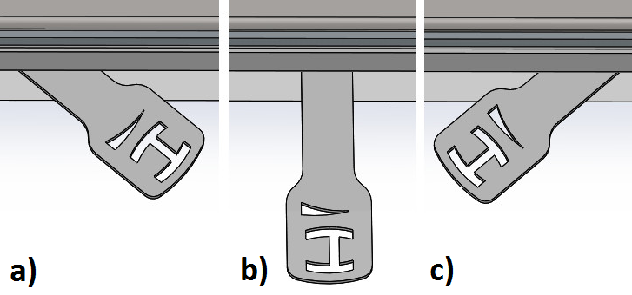

**Figure 13. Air settings; a) minimum air setting; b) air inlet opened in 50%; c) maximum air setting**

1. USE

The surface of the insert is covered with a special heat-resistance paint. After lighting the fireplace, this paint initially becomes soft (care must be taken not to scratch it then) and then hardens. Due to this process, an unpleasant smell is produced when the fireplace is lit for the first few times. It is recommended to make sure that the room is well aired during that time.

If pets or birds are kept in the room, they should be temporarily moved to another place.

In the initial stage of using the fireplace (for about 2 weeks), the manufacturer recommends maintaining a small flame by burning a smaller quantity of fuel at a lower temperature. This method of lighting the fireplace is intended to prevent cracks in the akubet lining, to avoid deformation of the fireplace structure or damage to the protective (paint) layer of the insert.

* 1. Types of fuel

Considering the design of our appliances, the most suitable type of fuel is the wood of deciduous trees, including: oak, hornbeam, ash, beech, birch.

Another acceptable type of fuel is lignite briquette. *In particular, we recommend using birch wood.*

The best fuel is wood which has been seasoned (for at least one year in a well-ventilated and dry place), cut and chopped into logs. We advise against using the wood of coniferous trees. Freshly cut or damp wood is not a good fuel, because it has a low calorific value. The burning of insufficiently dried wood may result in increased deposits of creosote in the combustion gas ducts, which may cause the glass panel to break.

**NOTE:**

**It is forbidden to burn waste fuel, liquid fuels and other types of fuel not recommended by the manufacturer of the fireplace insert.**

It is strictly forbidden to use the following as fuel for the fireplace: bituminous coal, the wood of tropical trees, all types of products containing chemical compounds such as petrol, alcohol, naphthalene, oil, waste and laminated panels containing adhesives.

* 1. Refuelling:
* fuel should be added when flames disappear over the layer of embers in the hearth; it is best to heap embers into a pyramid-like shape onto the grate (from both sides, to ensure a sufficient flow of air from underneath the grate for flames to appear) and then add slivers of wood;
* embers should not be heaped over the grate in an even layer, because it would significantly reduce the flow of air from under the grate and result in a build-up of gas in the hearth chamber and in the whole insert, which might lead to an explosion;
* wooden logs in the combustion chamber should be arranged in parallel to the plane of the door;
* before loading the hearth with a new portion of wood, remove ash from the grate and empty the ash pan if necessary.

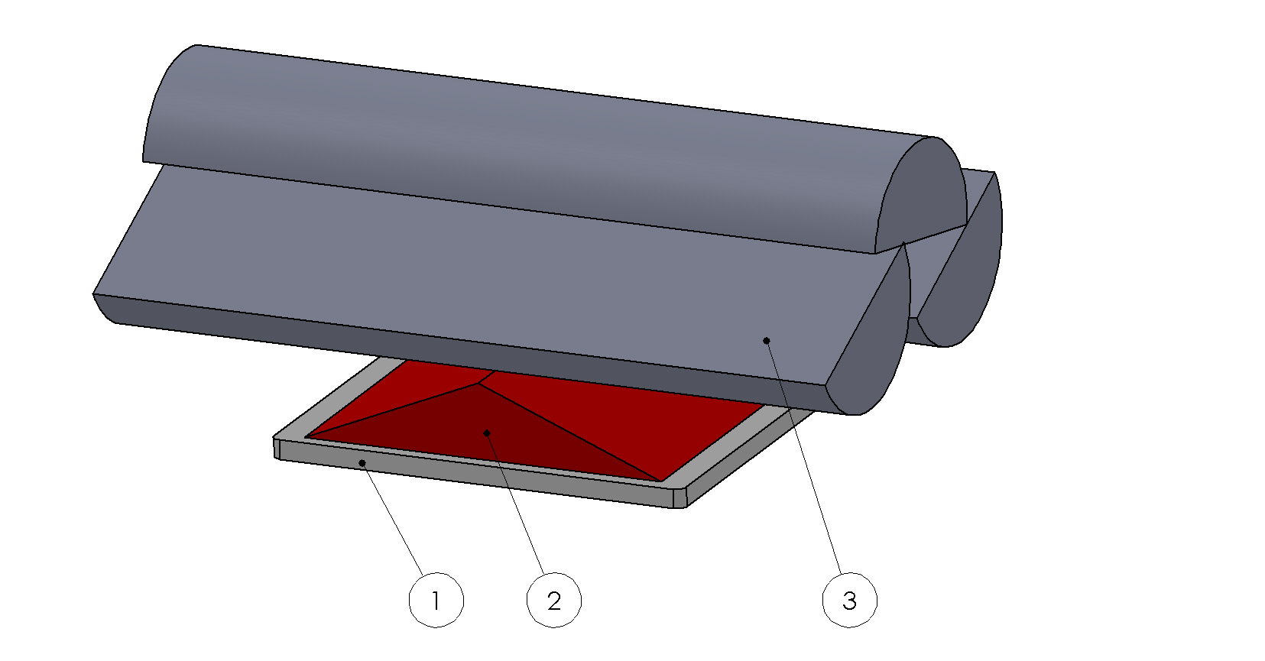

**Figure 14. The method of rearranging embers and stacking wood; 1 – grate, 2 – embers, 3 – slivers of wood**

8.2.1 Preventing the escape of combustion gases

To prevent the escape of combustion gases from the insert to the room during the opening of the door, it is recommended to:

* set the primary air regulator in the fully open position for about 10 seconds before opening the door (moving the lever of the throttle to its leftmost position);
* open the damper valve of the combustion gas throttle in the flue (if such a valve is installed in a given insert);
* move the door slightly ajar, wait a few seconds (until combustion gases disperse) and then slowly open the door of the insert;
* exercise caution when opening the door and after opening it, because burning pieces of wood may fall from the hearth;
* after adding an appropriate quantity of fuel, close the door of the hearth;
* when the fuel is well alight, set the air regulator in its original position;
* the optimum amount of fuel is specified in table no. 1÷4;

**NOTE:**

**Take care not to overload the insert with fuel. Overloading may cause permanent damage to its structure.**

* 1. Keeping the glass pane clean

The cleanliness of the glass pane depends on using appropriate fuel, as well as on:

* supplying a sufficient quantity of air for the burning process;
* optimum chimney draught;
* the method of operating the fireplace insert;
* the use of fuel with a moisture content of between 12%-20%

To keep the glass pane clean, it is advised to add the recommended quantity of fuel and to position it centrally on the grate and as far from the glass panel as possible (the same applies to briquettes – a distance of 5 to 10 mm should be maintained between them).

In the case of a build-up of tar on the glass pane, we recommend increasing the intensity of the burning process by opening the primary air regulator. The tar will burn off when the appliance is operating at full capacity.

* 1. Operation in adverse weather conditions and in the first period of use

In the first period of use or in adverse weather conditions (e.g. during a fog, on damp and rainy days, in weather with strong gusty winds or when outdoor temperature exceeds +15°C), the chimney draught may become too weak to remove all combustion gases. To offset this negative effect, the fireplace should be loaded with the smallest possible amount of fuel or additional draught regulators should be used.

* 1. Removal of ash

Depending on the amount and type of burning fuel:

* use a poker to rake the ashes through the grate into the ash pan;
* after raking the ashes with a poker, lift the grate, pull out the ash pan and empty it;
* the ash pan can only be emptied when it is cold; it should be done, at the latest, before lighting a new fire;
* before emptying the ash pan, please make sure that it does not contain any leftover embers which might cause a fire in the waste bin.

**NOTE:**

**Take care not to overfill the ash pan. If the ash pan is too full, it will hinder the inflow of air under the grate, hindering the burning process or, in extreme cases, even making it impossible to light the fireplace.**

The ash pan may **corrode** prematurely when ashes are left in it too long**.** The ash from burnt wood may be used as compost material or fertilizer.

* 1. General comments

Things to be done:

* make sure that the **door of the hearth (combustion chamber) and the door of the ash pan (if installed in a given insert) are closed (unless they need to be opened for maintenance purposes);**
* prior to lighting up after a prolonged shutdown period, check the flue pipe in the chimney and the hearth to make sure that they are unobstructed and clean;
* during the performance of any maintenance or operation-related tasks, please remember that the components of the insert can be very hot. Therefore, it is necessary to wear protective glasses;
* for any repairs of the insert use only spare parts produced by its manufacturer;
* all repairs must be performed by a qualified installer;
* during the operation and use of the fireplace insert, please follow the basic safety rules.

It is forbidden:

* to leave any flammable materials or items sensitive to high temperature near the glass of the insert;
* to use the appliance when its glass is broken;
* to extinguish the hearth fire with water;
* **to let children come near the appliance;**
* to make any structural changes or to alter the rules of installation and use without prior written consent of the manufacturer;
* **if any malfunctions are detected, the fire must be extinguished immediately.**

**NOTE:**

**In emergency situations, extinguish the fire by covering the fuel with sand or cold ash.**

**DO NOT USE WATER!**

**If the fireplace does not function correctly, any maintenance work may only be carried out after ensuring good ventilation of the rooms, as well as the assistance of another person equipped with a dry-powder extinguisher.**

**NOTE:**

When the burning process is slow, large quantities of organic products of combustion are produced, which may lead to the build-up and ignition of creosote in the chimney duct. As a result, the so-called chimney fire breaks out, which may spread to the whole building.

**In the case of a chimney fire, please do as follows:**

* cut off the inflow of air to the fireplace by closing the throttle of the cold air inlet;
* close the rotary damper valve of the combustion gas flue (if installed a given model);
* close the door of the fireplace tightly;
* dial 112 or 998 to alert the local Fire Department.

1. MAINTENANCE

To ensure safe and problem-free operation of the appliance, observe the following guidelines:

* perform periodic maintenance tasks in a timely manner – have the fireplace inspected by a specialized servicing company at least once a year;
* keep the following components clean: glass pane, combustion chamber with the ash pan and the chimney duct;
* empty the ash pan regularly - it may corrode when ashes are left in it too long;
* make sure that the combustion chamber is cleaned and serviced with a frequency which is appropriate for a given type of fuel;
* make sure that steel or cast-iron elements inside the insert are cleaned with appropriate tools such as: brush, scraper and poker; use protective gloves;
* **any maintenance activities may only be performed after the fire has been extinguished and the fireplace has cooled down;**
* the ceramic glass panel should be cleaned with an appropriate cleaning agent, avoiding its direct contact with steel and cast-iron elements of the appliance. The cleaning agents and products which are used to clean the glass may not contain abrasives, as they might damage (scratch) its surface;
* chimney ducts must be cleaned by a qualified chimney sweep company at least twice a year and it must be documented in the guarantee card;
* the inside of the fireplace must be cleaned and the airflow and the combustion gas outlet must be inspected.
  1. Periodic cleaning of the fireplace

To ensure an efficient burning process in the hearth of the fireplace insert, the combustion chamber, the grate, the flue and combustion gas ducts must be cleaned periodically.

|  |  |  |
| --- | --- | --- |
| **Component** | **Frequency** | **Tools and resources** |
| The convection surfaces of the fireplace insert and the pipes connecting it with the chimney duct – cleaning | As needed, but not less frequently than once a year or after a prolonged shutdown period | A brush made from a resilient material, vacuum cleaner, fireplace cleaning products. |
| Combustion gas duct, chimney - checking if the chimney is not obstructed and that the combustion gas installation is in a good condition | At least twice a year, after the heating season and after a prolonged shutdown period | Specialist chimney sweep company |
| Front glass pane | As needed | After it has cooled down – cleaning agents suitable for cleaning the glass of the fireplace |
| Grate and internal components of the insert | As needed | Vacuum cleaner, fireplace cleaning products |
| Maintenance of the combustion gas throttle - replacement of the gaskets of the glass pane and of the hearth door | At least once a year, after the heating season or as needed, depending on the degree of wear and tear | Servicing company authorized by the manufacturer |

1. TROUBLESHOOTING

During everyday use of the fireplace insert, the below described anomalies may become apparent in the case when the fireplace insert has been installed in a manner contrary to this *Operation and Installation Manual* and the applicable provisions of law.

10.1 The most frequent malfunctions and ways of eliminating them:

|  |  |  |
| --- | --- | --- |
|  | **Problem** | **Solution** |
| Smoke escapes to the room when the door is being opened | the door may be opened too abruptly, causing negative pressure in the combustion chamber | close the door slowly |
| the adjustable damper valve of the flue of the chimney duct is closed (if such a valve has been installed) | open the damper valve |
| insufficient amount of air in the room where the fireplace insert is installed | check the efficiency of the ventilation and make sure that the room is well aired |
| weather conditions |  |
| inadequate chimney draught | check the efficiency of the chimney installation |
| The heating efficiency is low or the fire in the hearth goes out | insufficient quantity of fuel in the hearth | add as much fuel as is required |
| the moisture content of the fuel is too high | use fuel with a moisture content of up to 20% |
| inadequate chimney draught | check the efficiency of the chimney installation |
| The heating efficiency is low despite the correct burning process in the hearth | inappropriate wood with a low calorific value is used | use wood with a higher calorific value instead |
| the moisture content of the fuel is too high | use fuel with a moisture content of up to 20% |
| the fireplace has been fuelled with thin and small pieces of wood which burn very quickly | place thicker logs in the fireplace |
| Soot accumulates on the glass and it does not burn off | the fuel burns too slowly and the temperature in the combustion chamber is too low | increase the amount of air in the combustion chamber, use fuel with a moisture content of up to 20% |
| the fireplace has been fuelled with wood of coniferous trees with a high resin content | use dry wood of deciduous trees instead |
| The appliance may be functioning incorrectly due to external factors | tall objects are situated too near the chimney | increase the height of the chimney or use a rotary chimney cowl cap or another type of chimney cowl cap |
| adverse weather conditions, e.g. wind or windless weather, low atmospheric pressure, high air humidity, fog, etc. | use a chimney cowl cap and, if it does not help, seek advice of a chimney expert to establish the cause of the problem |

1. NAMEPLATE

The nameplate is placed on the back wall of the appliance.

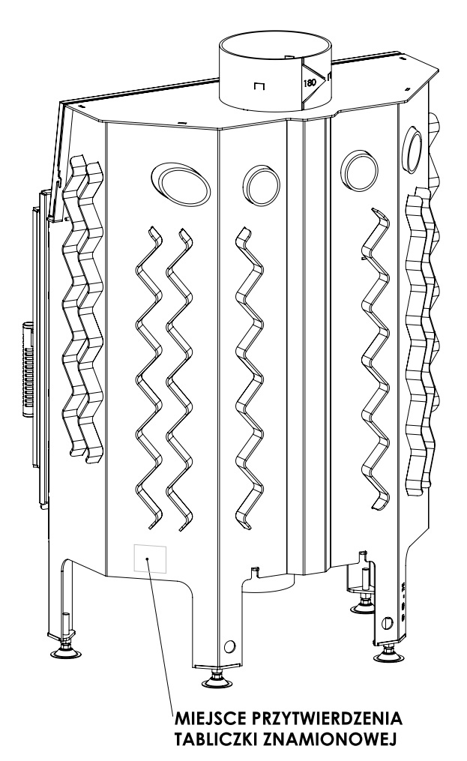



**Figure 15. The model of the nameplate and its location**

1. INSPECTION RECORDS

|  |  |
| --- | --- |
| REGISTER OF INSPECTIONS OF THE CHIMNEY | |
| Inspection | Date, signature and stamp |
| Inspection | Date, signature and stamp |
| Inspection | Date, signature and stamp |
| Inspection | Date, signature and stamp |
| Inspection | Date, signature and stamp |
| Inspection | Date, signature and stamp |
| Inspection | Date, signature and stamp |

|  |  |
| --- | --- |
| REGISTER OF INSPECTIONS OF THE FLUE PIPE | |
| Inspection | Date, signature and stamp |
| Inspection | Date, signature and stamp |
| Inspection | Date, signature and stamp |
| Inspection | Date, signature and stamp |
| Inspection | Date, signature and stamp |
| Inspection | Date, signature and stamp |
| Inspection | Date, signature and stamp |

1. NOTES