

SETTING AND ADJUSTMENT INSTRUCTIONS

GUILLOTINE-TYPE
DOOR
Version 0.1 – 13.10.2016

OPENING AND CLOSING OF THE DOOR

A guillotine-type door can be moved up or down as well as sideways.
To open the door (e.g. for the purpose of cleaning the insert after use):
- move the guillotine-type door to its lowest position until it touches the adjustment screws on the stopper of the sliding device;
- press down the lever protruding from the side of the wall to release the pin in the door lock (the lever is on the right or left side of the insert);
- open the door holding the handle;
- after opening the door, perform the intended maintenance tasks or clean the insert.
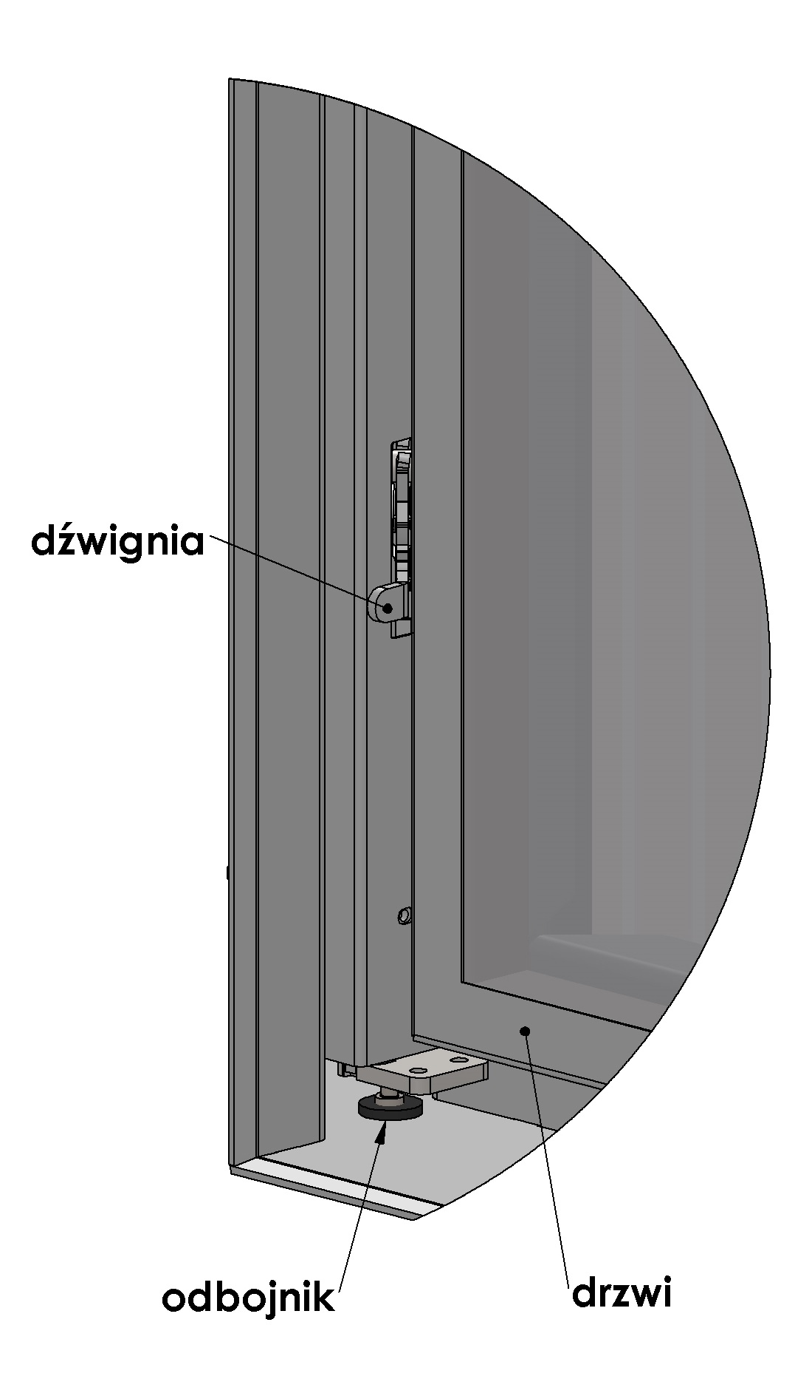
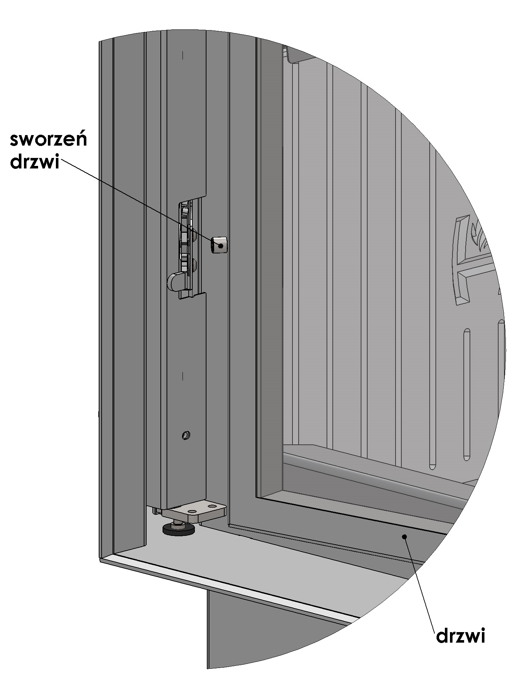

door pin

lever

stopper
door
door

Figure 1. Guillotine-type door – the opening and closing of the door

The door of the insert should be closed as follows:
- perform a swinging movement and press the door down - the pin will click into its place in the lock, then lift the door upwards, simultaneously pressing it down (until characteristic clicking sound heard). Hold the handle when lifting the door.
Do not slam the door shut otherwise the glass could crack or break.

